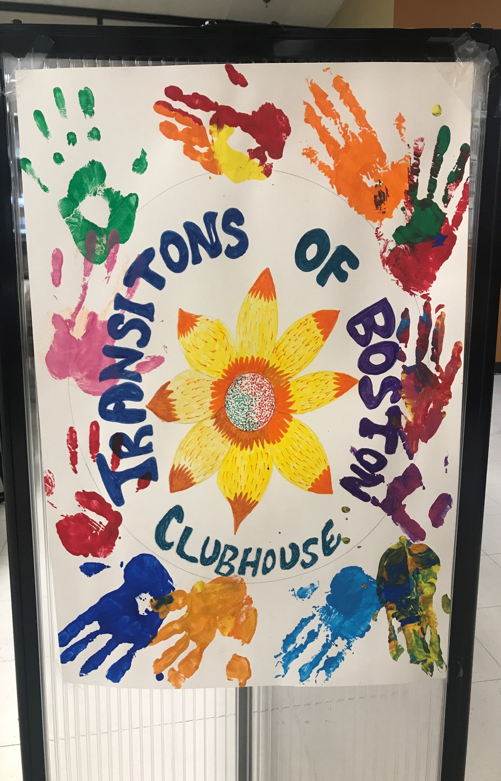
VOLUME #17 June & July 2024 Newsletter
TRANSITIONS OF BOSTON CLUBHOUSE
1500 Dorchester Ave.
Dorchester, MA 02122

Phone: 617-379-5661
Fax: 617-541-6817
Website: Transitionsofboston.com
Facebook: @TOBClubhouse

In This Issue:
- Cover Page ………… 1
- Our Editor’s Page ... 2
- Working Units &
Book Club ……... 3 & 4
- Walking Group… 5
- Arts & Craft and
- Painting Groups.. 6&7
- Food Service /
Recipe Meal …. 8 - 9
- Happy Birthdays … 10
- Juneteenth Celebration
……………………. 11 – 13
- Members In the Spot
Light ……………. 14 – 17
- Welcome New Staff
……………………..18 -19
- Visit of Mass Mental
Health & Brigham & Women’s Hosp. Resid.
………………….. 20 – 21
- TOB Outings… 21 - 24
- Contact Us …..... 25



Transitions of Boston Newsletter
“Transitions of Boston Clubhouse guarantees…
A right to a place to come.
A right to meaningful work.
A right”

EDITOR’S NOTE
Hello, Dear TOB Members and Friends!

I hope this newsletter finds you well and happy. As the summer is coming to an end, I would like to share with you some of the wonderful moments that we had at TOB in the past months. As you may recall, we organized a special outing to Revere Beach to see the amazing sand sculptures created by talented artists from all over the world. It was a memorable day filled with fun, laughter, and learning. In this newsletter, you will find some of the pictures that we took at the beach, as well as some interesting facts and stories about the event and the location. You will also hear from some of our Members who participated in the outing and shared their impressions and feedback with us. We hope you enjoy reading this newsletter and reliving the experience with us. As the newsletter editor, I would like to thank all of you who joined us for the outings and made it such them a success. I would also like to thank our Staff who worked hard to plan and coordinate the events and outings and ensure that everything went smoothly. It was a pleasure to see you all having a good time and bonding with each other. I think that outings like this are a great way to explore new places and cultures, as well as to strengthen our sense of Community and belonging. I am looking forward to our next outing to Canobie Lake and I hope you are too. Please stay tuned for more information and announcements about our upcoming events and activities. And as always, if you have any suggestions, comments, or questions, please feel free to contact us anytime. We value your input and feedback, and we want to make TOB the best place for you.
Thank you for being part of our TOB Family and see you soon!

Editor-In-Chief:
Valerie Lucien;
Member since October 2023

Working Units & Groups
Book Club Review
A Journey into Dystopia: Book Club Tuesdays with The Giver by Lois Lowry
Have you ever wondered what it would be like to live in a world where everyone is the same, where there is no pain, no war, no suffering, but also no color, no music, no love? That is the premise of The Giver, a classic novel by Lois Lowry that explores the themes of memory, identity, freedom, and choice.

In our book club, led by Valerie Lucien, a member and editor at TOB, we read the book aloud in weekly sessions and discuss the characters, the plot, and the messages of the story. We also test our comprehension and retention with chapter quizzes and fun activities. We started reading the book in June 2024 and we are now halfway through it.
The Giver follows the life of Jonas, a 12-year-old boy who lives in a seemingly perfect community where everything is controlled and regulated by a set of rules. Jonas is assigned to be the Receiver of Memory, a special role that requires him to receive the memories of the past from an old man called the Giver. As Jonas learns more about the history of humanity, he begins to question the society he lives in and the choices he must make.
Some of the questions we ask ourselves and each other in our book club are:
- How does Jonas’s character change throughout the story?
- What are some of the advantages and disadvantages of living in the same community?
- What are some of the memories that Jonas receives and how do they affect him?
- What are some of the symbols and motifs that the author uses to convey her message?
- What are some of the ethical dilemmas that Jonas faces and how would you handle them?
We also encourage our members to share their personal opinions and impressions of the book, as well as their predictions for how the story will end. We aim to create a friendly and respectful environment where everyone can express themselves and learn from each other.
If you are interested in joining our book club, please contact Valerie Lucien at TOB Clubhouse or visit our website for more information. We meet every Tuesday from 11:00am – 12:00pm in the TOB Work Unit Common Area. We hope to see you soon!

Working Units & Groups
Book Club Review
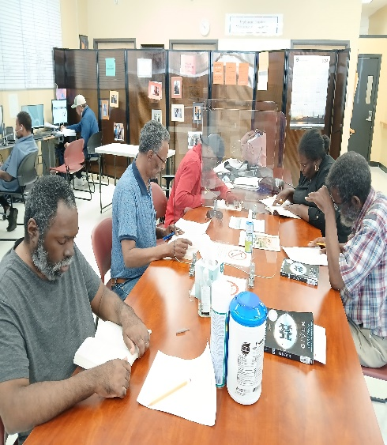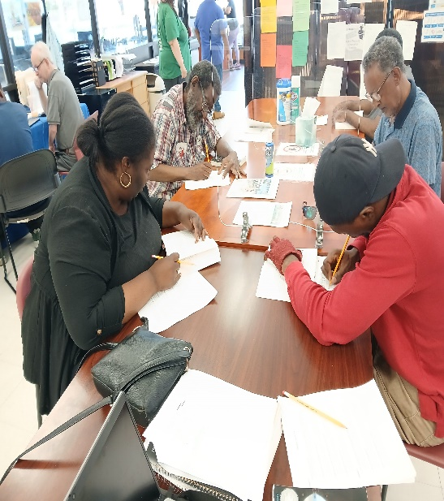
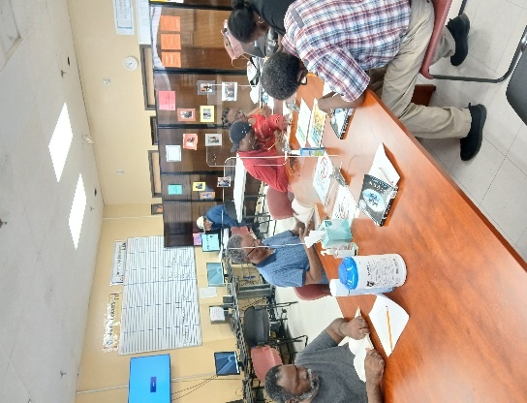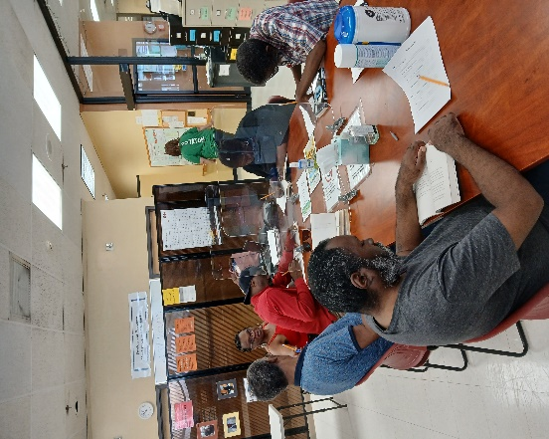

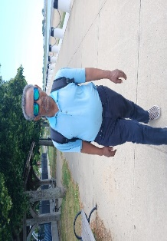
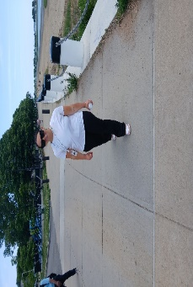
Working Units & Groups (cont’d)
Health & Wellness/Walking Group
Walking In Sunshine: TOB Members Enjoy the Benefits of Outdoor Exercise

Another highlight of our summer activities was the Community Walking program, which started on May 31, 2024, and is held every other Thursday as part of our Health and Wellness Group led by Alex W. This program is designed to promote physical and mental well-being, as well as to foster social connections among our members. We chose Malibu Beach as our first walking venue, and we were delighted by the beautiful scenery and the refreshing breeze. Many of our members enjoyed the walk and commented on how relaxing and energizing it was.
Here are some of their testimonials:
- "I love walking on the beach. It makes me feel calm and happy. I also like chatting with my TOB friends and getting to know them better." – Anibal Rodriguez, Member

- "Walking is good for my health and my mood. I feel more active and positive after a walk. I also appreciate the opportunity to see different places and learn new things." – Valerie L., TOB Chronicle Newsletter Editor and Member

- "This is a great program. It helps me stay fit and motivated. I also enjoy the company of other TOB members who share similar interests and experiences." – Dwight, Member

We are glad that the Community Walking program has received such a positive response from our members. We will continue to explore other walking venues in the future, such as Carson Beach, Castle Island, and more. We hope you will join us for our next walk and experience the benefits of walking together. Please check our website and social media for the latest updates and announcements. In the meantime, enjoy the showcase of photos that we took at Malibu Beach in June and July 2024. See if you can spot yourself or your friends in the pictures!
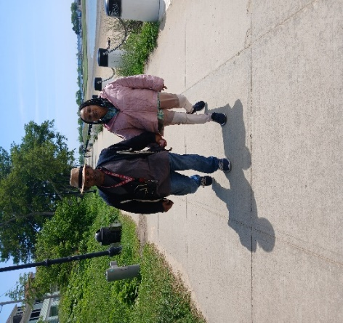
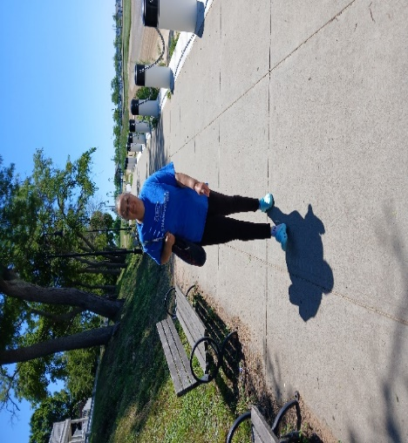
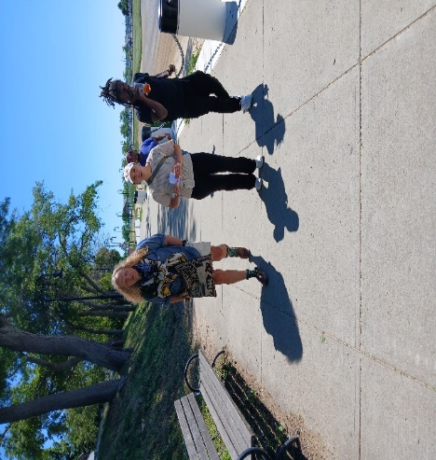

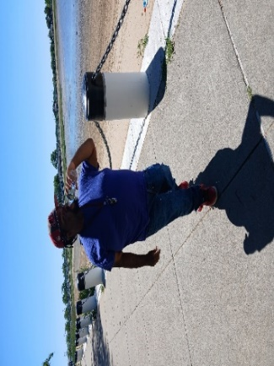
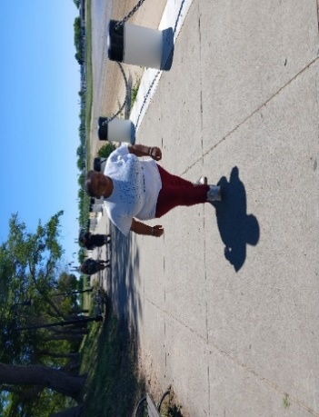

Working Units & Groups (cont’d)
Arts & Crafts/ Painting Saturdays

Are you looking for a fun and creative way to spend your weekends? Do you want to learn new skills and express yourself through art? Then join us for Arts & Crafts/Painting Saturdays where you can explore different techniques and materials and create your own masterpiece. Whether you are a beginner or an experienced artist, you will find something to suit your interests and abilities. You can choose from a variety of projects, such as: Arts & Crafts, Jewelry Making, Painting, and more.

Each session is led by our Clubhouse Worker, Alex W., who will guide you through the steps and offer feedback and advice. You will also have access to all the materials you need. All you must do is bring your imagination and enthusiasm.
The Arts & Crafts/ Painting Groups are held on Saturdays from 1:00 PM- 2:30 PM
We look forward to seeing you at our Arts & Crafts/ Painting Saturdays, where you can unleash your inner artist and have fun at the same time. It's a great way to relax, socialize, and learn something new. Don't miss this opportunity to discover your hidden talents and make some amazing art.

- In this newsletter, we want to celebrate the achievements of our members who have participated in the Arts & Crafts/ Painting Saturdays. You have impressed us with your creativity, skill, and passion for art and jewelry making. Here are some of the stunning works that you have created and shared with us. Congratulations on your amazing
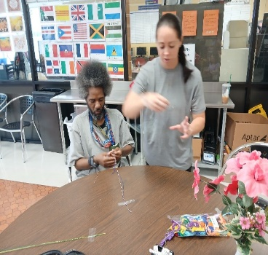
art!
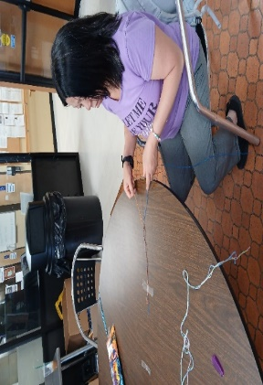
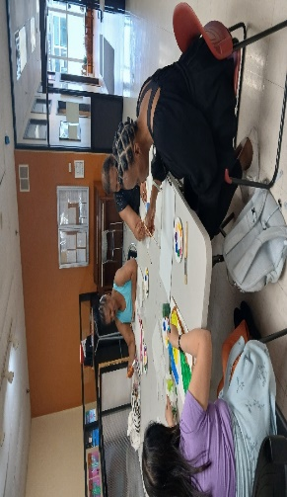
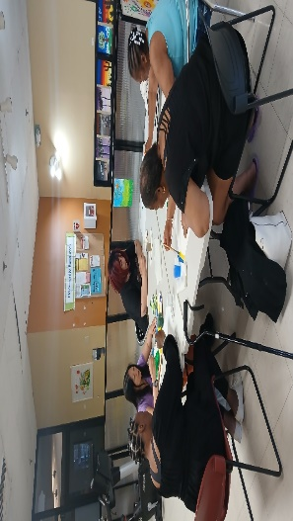
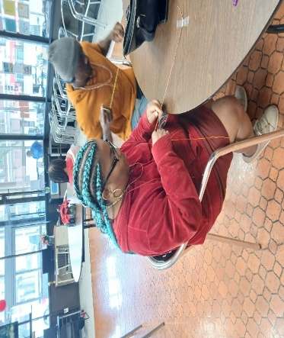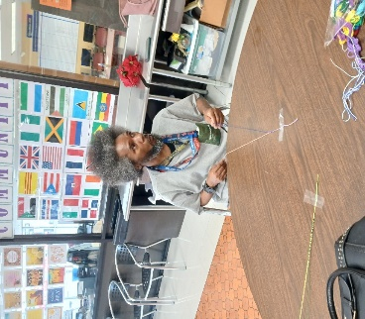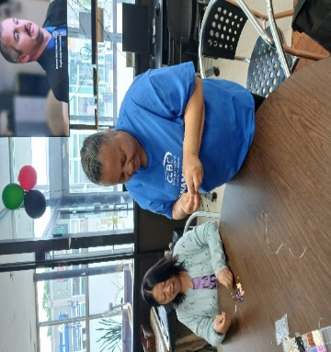

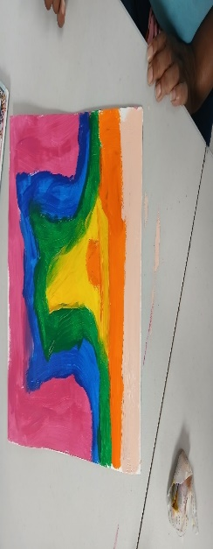

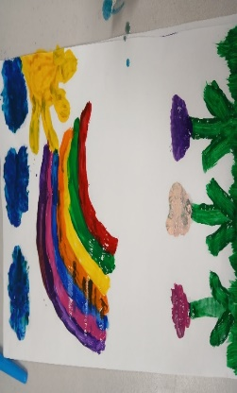
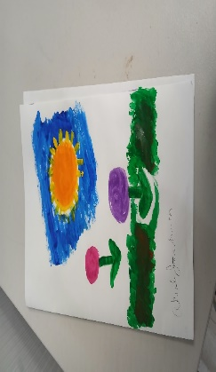
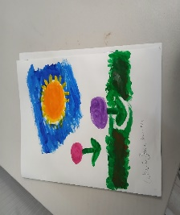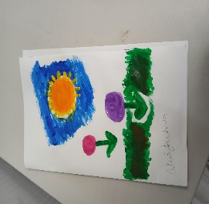

Food Service Unit
Monthly Recipe Meal
Every month we select a monthly recipe meal that features a delicious and easy recipe that you can try at home. For the month of June, one of Valerie Lucien’s favorite family recipe was chosen out of the Recipe Box.
Haitian Macaroni Au Gratin and Fried Chicken
Valerie Lucien, who shared her family's favorite dish for special occasions: Haitian Macaroni Au Gratin and Fried Chicken. This is a hearty and flavorful meal that will make you feel like you are in the Caribbean.
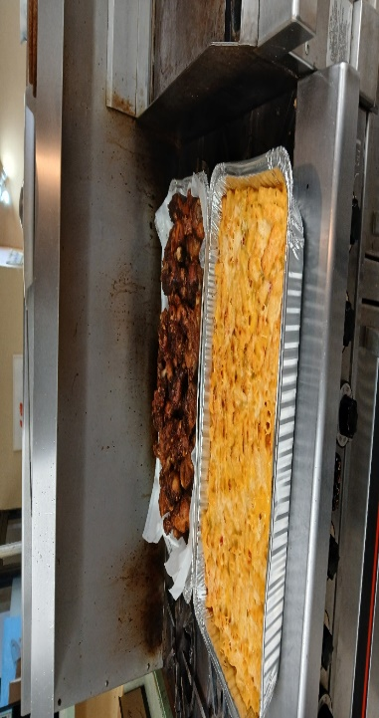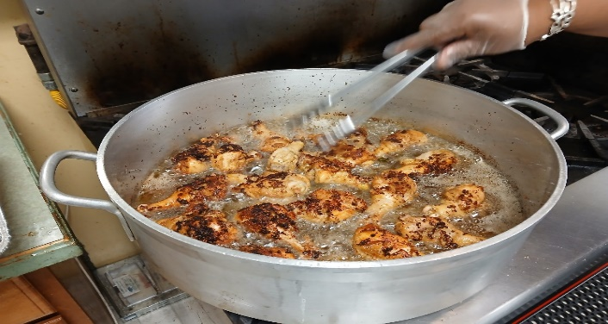
To make the macaroni au gratin, you will need:
- 1 pound of rigatoni macaroni
- 4 tablespoons of butter
- 4 tablespoons of flour
- 4 cups of milk
- Salt and pepper, to taste
- 2 cups of shredded cheddar cheese
- 1/4 cup of grated parmesan cheese
- 1/4 cup of breadcrumbs
The steps are:
- Cook the macaroni according to the package directions, then drain and set aside.
- In a large saucepan over medium heat, melt the butter and whisk in the flour. Cook for a few minutes, stirring constantly, until smooth and bubbly.
- Gradually whisk in the milk, stirring well to avoid lumps. Season with salt, pepper, and nutmeg, and bring to a boil. Reduce the heat and simmer, stirring occasionally, until thickened, about 15 minutes.
- Stir in the cheddar cheese and half of the parmesan cheese until melted and smooth.
- Preheat the oven to 375°F and grease a 9x13 inch baking dish.
- Transfer the macaroni to the prepared baking dish and pour the cheese sauce over it, spreading it evenly. Sprinkle the remaining parmesan cheese and the breadcrumbs on top.
- Bake for 25 minutes or until golden and bubbly.

Valerie says this recipe serves 8 people, but you can easily double it if you have a larger crowd. She also recommends using fresh lime juice and garlic for the best flavor. Thank you, Valerie, for sharing this delicious recipe with us!

Food Service Unit
Monthly Recipe Meal (Cont’d)

To make the fried chicken, you will need:
- 4 chicken legs and 4 chicken wings
- Juice of 2 limes
- 4 cloves of garlic, minced
- 2 teaspoons of salt
- 1 teaspoon of black pepper
- 1 teaspoon of thyme
- 1/4 teaspoon of allspice
- 2 cups of vegetable oil
- 1/4 cup of flour

Rinse the chicken pieces and pat them dry with paper towels. Squeeze the lime juice over them and rub with the garlic, salt, pepper, thyme, and allspice. Marinate for at least 30 minutes or up to overnight in the refrigerator.
- In a large skillet over high heat, heat the oil until shimmering. Dredge the chicken pieces in the flour and shake off the excess. Fry them in batches, turning once, until golden and crisp, about 10 minutes per side. Drain on paper towels and keep warm in the oven.

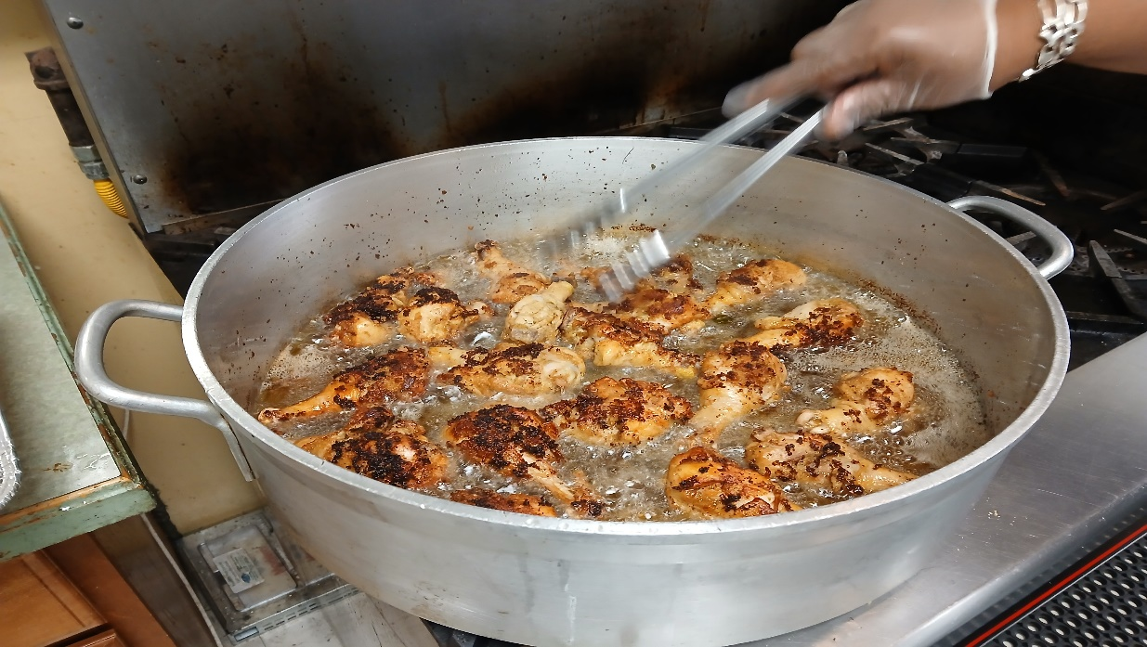

- Serve the macaroni au gratin and fried chicken with a green salad and enjoy!
Food Service Unit
Monthly Recipe Meal (Cont’d)
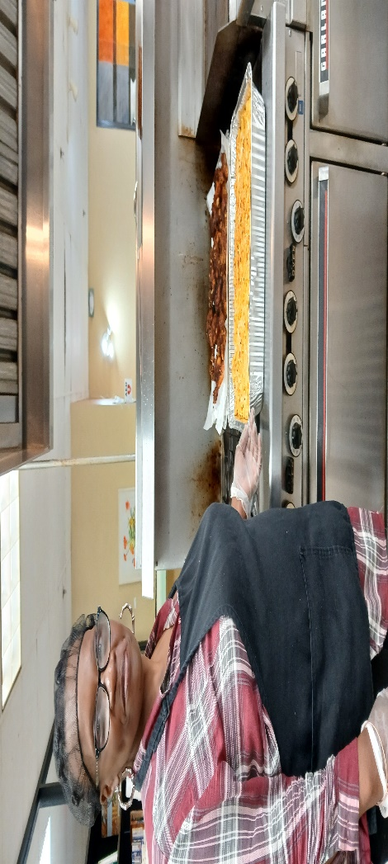
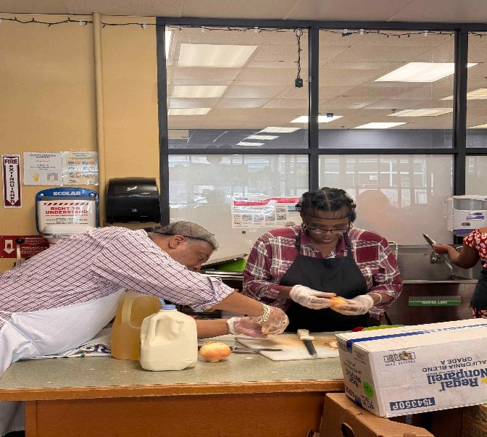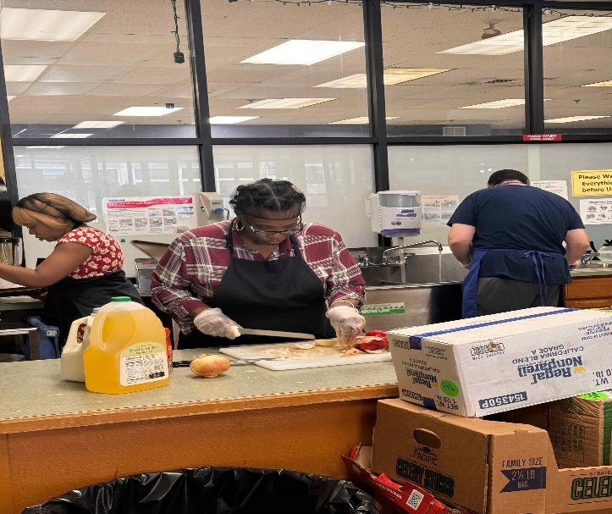
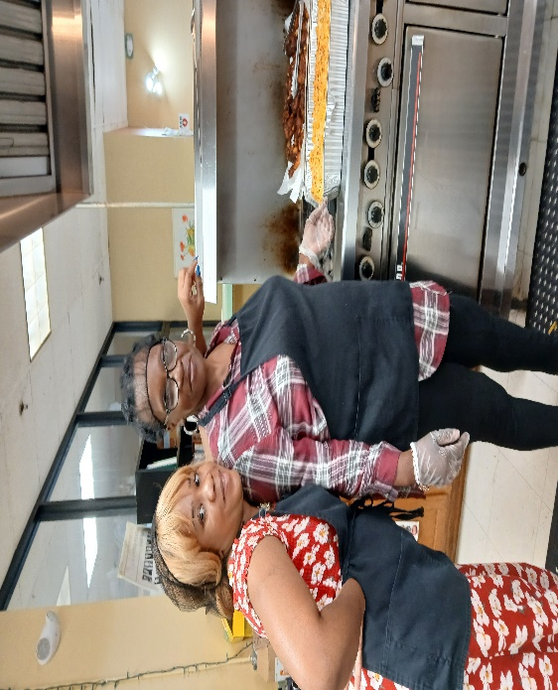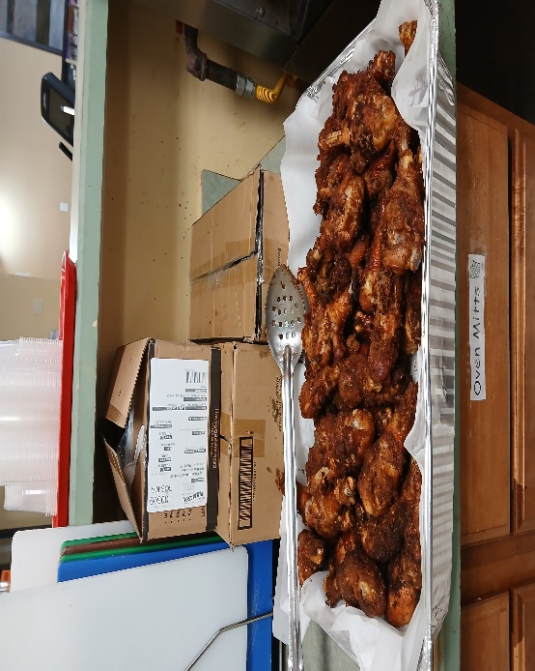

Members Birthday Celebration in June & July



June July
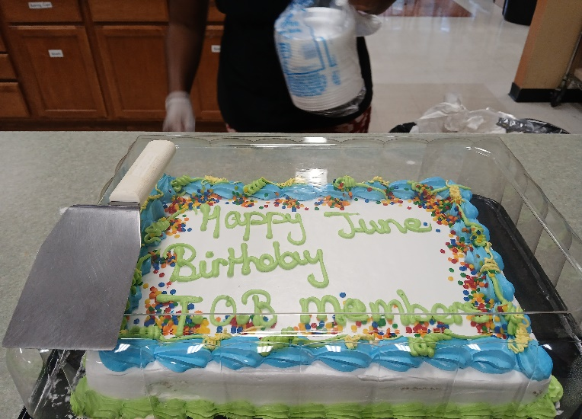

Djeison Barros 07/03
Janet Scruggs 07/07
Louis Cyprien 07/09
Wallace Carpenter 07/13
Ronald Bryant 07/14
David Simms 07/14
Omolayo Soremekun 07/24
Valerie Lucien 07/28
Steven Campbell 07/30

Victoria Manter 06/02
Emanuel Monteiro 06/03
Erick Jones 06/08
Worku Aragaw 06/07
Adilson Centeio 06/08
Desmond Springer 06/10
Kevin Armstrong 06/13
Nathan Kindle 06/19
Akeila Jackson 06/20
Shirley Rogers 06/22
Abigail Seicol 06/22
Ralph Kelley, III 06/23
Tina Smith 06/24
Kathryn Johnson 06/25
Eddie Cutanda 06/27
Apollo Gross 06/27
Paul Massop 06/27
Shawn Weathers 06/29

Juneteenth Luncheon & Program

Juneteenth 2024 Celebration


Tuesday, June 18, 2024







Transitions of Boston Clubhouse
3rd Annual Juneteenth Celebration
June 18, 2024

Celebrating Juneteenth
On June 19, 2024, we Celebrated Juneteenth, also known as Freedom Day or Emancipation Day, commemorates the end of slavery in the United States on June 19, 1865, when the Union Army arrived in Galveston, Texas, and announced that all enslaved people were free. This was more than two years after President Lincoln had issued the Emancipation Proclamation, which declared that all enslaved people in the Confederate States were free as of January 1, 1863. However, due to the ongoing Civil War and the lack of enforcement, many enslaved people remained in bondage until the end of the war.

Juneteenth is the oldest nationally celebrated event marking the end of slavery in the United States. It has been recognized as a State Holiday or special day of observance in 47 States and the District of Columbia. It is also celebrated internationally in countries such as Ghana, Japan, South Korea, and Israel. Juneteenth celebrates the freedom, resilience, and contributions of African Americans to the American society and culture. It is also a time to reflect on the ongoing struggle for racial justice and equality in the country.

At TOB, we celebrated Juneteenth by hosting a special event featuring Member’s readings, music, poetry, and food. We learned about the history and significance of Juneteenth, as well as the challenges and achievements of the African American Community. We also enjoyed some traditional dishes, such as fried chicken, mac & cheese, rice and peas, salad, fruit and dessert. It was a wonderful and educational experience that brought us closer together as a Diverse Community. We hope you enjoyed learning about Juneteenth and its importance to our nation's history and culture. We encourage you to continue exploring and celebrating the diversity and richness of the African American Heritage and the African diaspora. Thank you for being part of our TOB Family and for sharing your talents of singing music, reading poetry, and stories with us. We look forward to seeing you at Transitions of Boston Clubhouse. Until then, stay safe and happy!

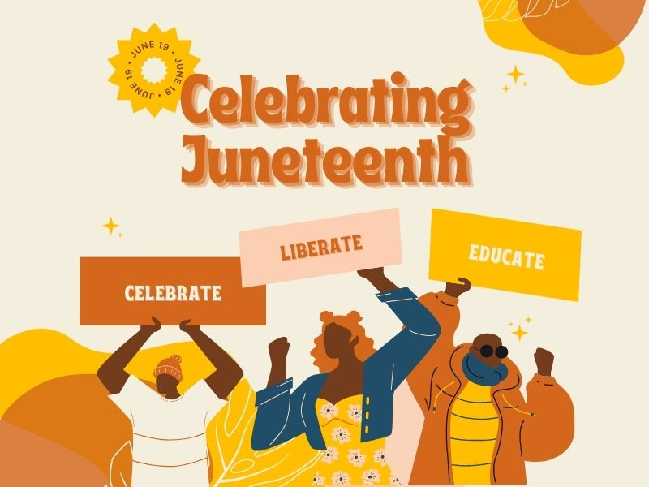

Juneteenth Annual Luncheon & Program Celebration
June 18, 2024
Happy Juneteenth

By: Dwight Fairbairn

June 19, 1865 the day we realize Slavery met its demise,
Did it die or put on a new disguise, did we rise like the days sunlight;

Our minds set on one life, we still cry things hard to come by,
Still feel pride with nothing to eat at lunch time,
Its crunch time,

Still in chains; get locked away in a dungeon;
Some a give their Soul away for comfort,
What has it come to;

I can tell you what the one do; cause the one doing is you.
Our Father had a dream and it’s come true it a chance I won’t lose,
We Free;
“Happy Juneteenth”
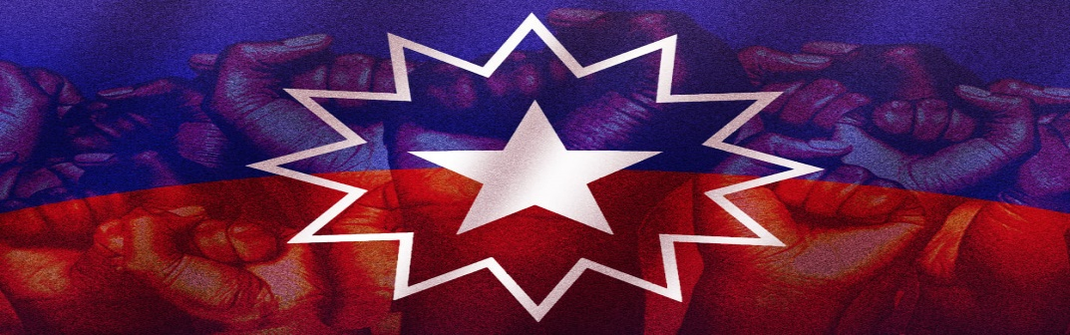

Members In The Spot Light

As Dean of the College of Liberal Arts
University of Massachusetts Boston
I am pleased to announce that

Paul Massop

has earned a place on the Dean’s List by virtue
of a fine academic record in the
Spring 2024 Semester

Pratima Prasad, Interim Dean
******************************************************************
Tina Smith receives her reward for the NAMI Walk 2024
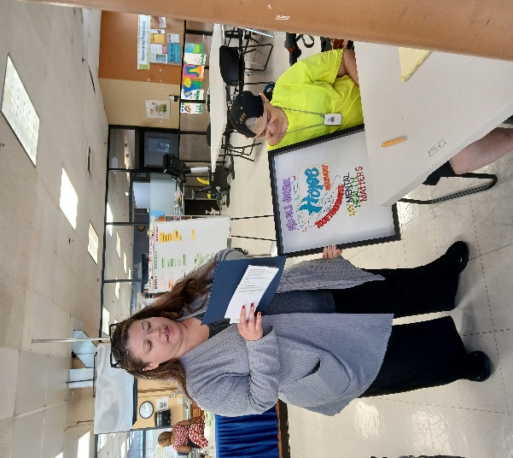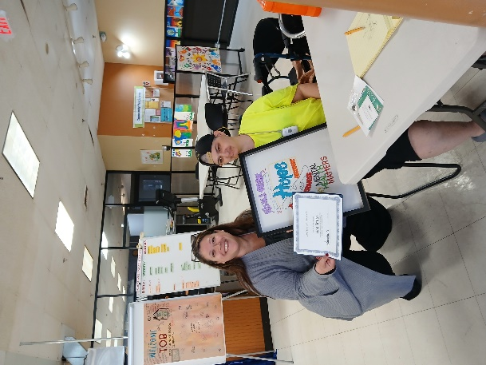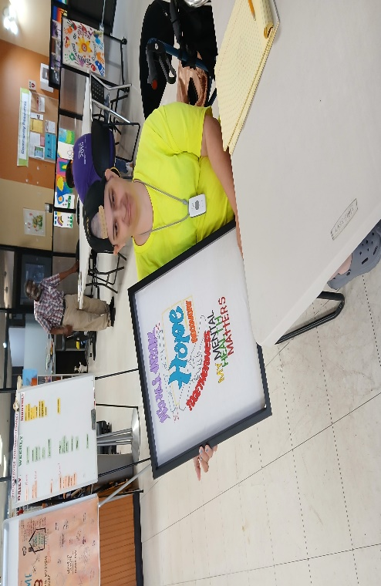
Tina was recognized by the Director of Bay Cove Human Services, Lisa Morishanti, during the Morning Meeting at Transitions of Boston Clubhouse on June 27, 2024. She received warm applause and congratulations from her Peers and TOB Staff. She posed for some pictures with her Awards, which included a framed T-shirt, a gift card, and a certificate of achievement. Tina was also Awarded and Recognized in May 2024 as the Winner for her T-Shirt Drawing and Design the Official 2024 NAMI and Bay Cove T- Shirt Competition.
Members In The Spot Light (Cont’d)

Valerie Lucien
We are thrilled to announce that one of our Clubhouse Members and newsletter editor, Valerie Lucien, has been accepted into the Addiction Counselor Education Program (ACEP) at the Manning College of Nursing and Health Sciences at the University of Massachusetts-Boston. This is a prestigious and rigorous program that prepares students for a career in helping individuals who suffer from Substance Abuse Disorders. Valerie's passion and dedication for this field are admirable, and we are proud of her accomplishment.

Valerie's interest in becoming an addiction counselor also aligns with her goal of becoming a Certified Peer Specialist through The REAL Program, which trains people with lived experience of Mental Health challenges to provide Peer Support and Advocacy. Valerie believes that sharing her personal story and recovery journey can inspire and empower others who are facing similar challenges. She is a valuable member of our Clubhouse Community, and we appreciate her contributions to our newsletter and other activities. Please join us in congratulating Valerie on her acceptance into the ACEP Program and the participation in Certified Peer Specialist 8-week Training through The REAL Program. She will begin her AECP program in the fall of September 2024. She will be starting the REAL Program Training on August 13, 2024. Let us join in wishing Valerie all the best in her studies and future career. Valerie, you are an inspiration to us all, and we are so happy for you!

Members In The Spot Light (Cont’d)
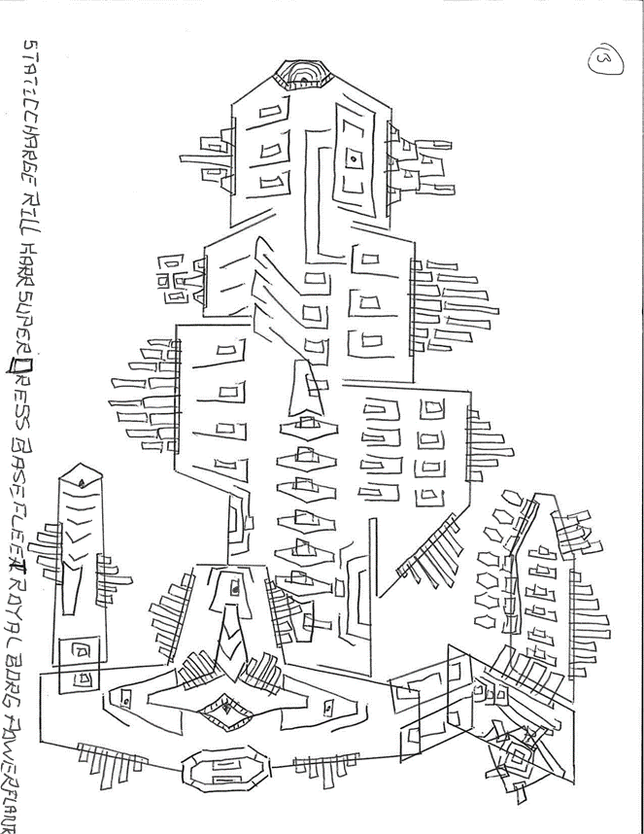
Ralph Art Work
Members In The Spot Light (Cont’d)

Members In The Spot Light (Cont’d)

Ralph Art Work - # 2
Members In The Spot Light (Cont’d)
Members In The Spot Light (Cont’d)
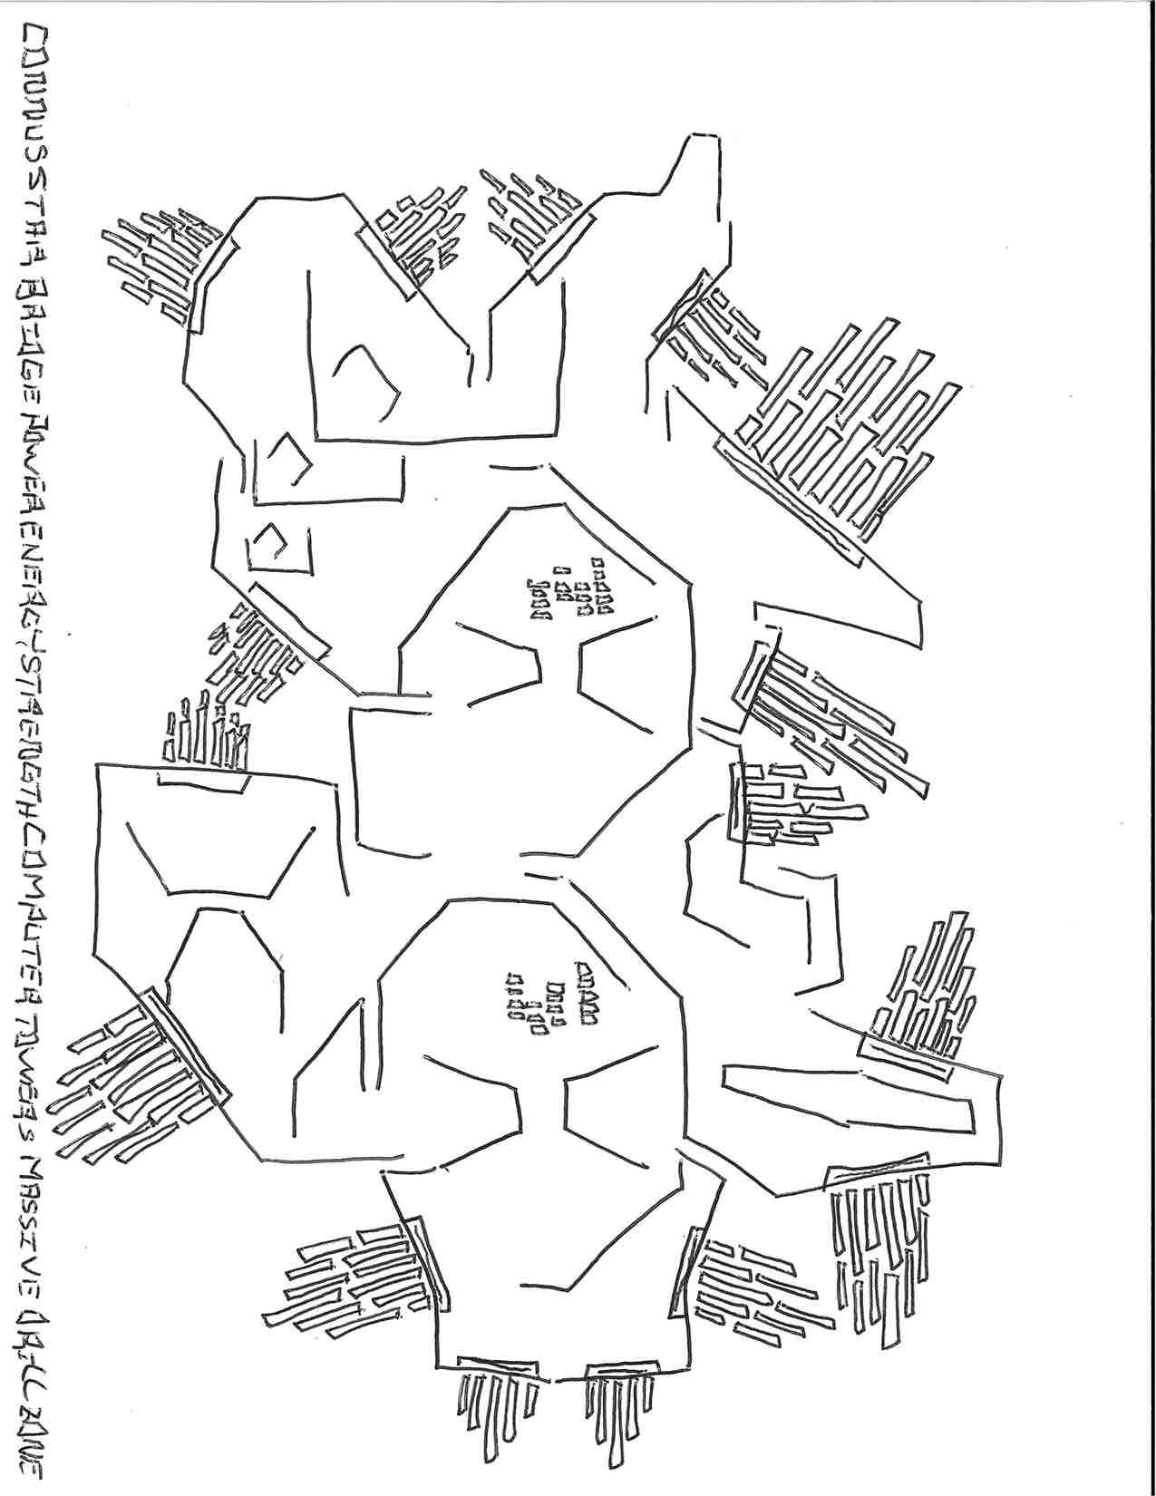
Ralph Art Work # 2

Welcome New Staff
Meet Alex Wyse, Our New Membership & Social Unit Staff Member
If you have visited the Clubhouse recently, you may have noticed a new face among our Staff. Alex Wyse joined us in June 2024 as our new Membership Staff Member, she has been busy updating our website, creating slide shows, and getting to know our
Members. Alex is a creative, friendly, talented, helpful, and devoted staff member who is always ready to lend a hand or a listening ear. She is passionate about working with our Members and helping them achieve their goals and aspirations. We are delighted to have Alex on board, and we want to introduce her to you in more detail. We asked her some questions about herself, her job, and her impressions of TOB. Here are her answers:
- How do you feel about being a new staff member at TOB?
- I feel very welcome and accepted. I’m enjoying myself very much. I love meeting all the Members and getting to know everyone.
- What are your main responsibilities and tasks working in the Membership Unit?
- I help Members with various goals and anything else they are working on. My tasks are to help with the Website, and updating the slides that are shown throughout the Clubhouse. I work on the Monthly Calendar and making outreach calls to Members who are not in attendance at the Clubhouse as well as working with the members that are in attendance. I help with Coverage of the Front Desk schedule, help facilitate the Health and Wellness Group, the monthly wall display, and decorating the Clubhouse for Birthday Celebrations, Holidays, as well as Special events.
- What are some of the skills and talents that you bring to this job?
- I love helping others. I am good at multitasking and can work well in a fast-paced environment. I am a team player and love collaborating with Staff and Members of the Clubhouse. I love being able to help solve a problem or figure out an issue someone may be facing. I feel I am a positive person who is enthusiastic, a good listener, patient, reliable, creative, and adaptable.
- What are some of the challenges and opportunities that you face in this job?
- It has been difficult when I can’t get in contact with members on the phone or haven't been able to meet with them in person. I am however loving participating in the many activities and special events that the TOB has to offer. Finally, having the opportunity to get people interested in coming to the Clubhouse and participating in the different groups makes me very excited.
- How do you interact with the members and what do you learn from them?
- I’m not afraid to go up to members and introduce myself and ask them if there is anything that they would like to work on or anything they may need help with. The members have taught me so much about the clubhouse and how things are done at TOB. Members share what they like to do at TOB, as well as give me feedback and suggestions on what they would like to do or see happen more at the Clubhouse. And finally learning about the cultures represented by the Diversity Wall, learning from speaking to members about their ethnicity and heritage backgrounds, and sampling dishes from around the world through the Recipe of the Month, when members get to shine as the kitchen chef for a day and lead the kitchen staff on how to prepare their recipe.

We hope you enjoyed getting to know Alex a little better. If you see her at the Clubhouse, don't hesitate to say hello and ask her for help with anything related to the Clubhouse, the Work Units, or the Groups. She is very approachable and friendly, and she is always happy to assist you. You can also reach her by email at
awyse@baycove.org or by phone at (617)379-5660 or at (617)379-5661. Welcome, Alex, and thank you for being a part of our TOB Family!

Welcome Back, MJ!
We are delighted to announce that MJ has returned to TOB as an Education and Employment Specialist.

MJ was an UMass Intern who did his internship at TOB, assisting members with various aspects of their Educational and Employment goals. He helped them create and follow the SMART goal process, write resumes, search for jobs, and practice mock interviews. He also participated in many of the clubhouse activities and programs, such as the Health and Wellness Group, the Book Club Group, the Soft Skills Group, the Employment and Education Work Unit, and more. MJ Graduated from UMass Boston with a BA in Psychology, and he is planning to apply for a Master's Degree in LMHC at UMass Boston after taking a year off. He is passionate about Mental Health and helping people achieve their full potential. He is also a great team player and a friendly person who enjoys connecting with others. As an Education Specialist, MJ will continue to support the Members in their Educational endeavors, as well as provide guidance and resources for their career development. He will also collaborate with other Staff Members and external partners to ensure the quality and effectiveness of our educational programs and services. We are very proud of MJ's achievements, and we are excited to have him back as a Staff Member. We hope you will join us in giving him a warm welcome and congratulating him on his new role. You can reach him by email at mvyliparambil@baycove.com or by phone at 646-749-6943.
Here are some questions we asked MJ about his return to TOB:
- How does it feel to be back at TOB as a staff member?
It feels welcoming coming back to TOB and I aim to work with all the Members to help them reach their goals.
- What are some of the skills and knowledge you gained from your internship and your studies?
The Members and Staff taught me how to engage with the needs of the Members at the clubhouse and how to offer help to those struggling with different problems whether it be addiction, future goals, education etc.
- What are some of the goals and challenges you have as an Education/Employment Specialist?
I would like to motivate more Members to further their education and seek employment.
- What are some of the things you enjoy most about working at TOB?
The engagement with the community and tackling problems together has been a very productive task from TOB.
- How do you balance your personal and professional life?
On my days off I genuinely unwind, focusing on myself and taking care of my own Physical and Mental Health. I also meditate when I feel stressed.

Remembering Those Who Have Lost A Loved One:
A Message of Sympathy and Support
We understand how difficult it is to lose a Loved One, and we want to express our Sincere Condolences to our Staff Members who have recently experienced this loss. Our Hearts and Prayers go out to: Kante Thorpe, Christopher Holloway, Harmony Washington, Kevin Booth and Priscilla Humphrey, who have each faced the passing of a Family Member in the past month. We hope that they can find comfort and strength in their memories and in the support of their colleagues and friends. We also want to remind them that they can access our employee assistance program, which offers free counseling and other resources to help them cope with their grief. Please do not hesitate to reach out to us if you need anything during this challenging time. You are not alone, and we are here for you.

A Visit from MMHC & Brigham & Women's Residents:
A Learning Experience for Both Sides
On June 7, 2024, we had the pleasure of hosting a group of residents from Brigham and Women's Hospital, who came to learn more about our clubhouse and the services we offer to our members. The residents are doctors who specialize in psychiatry and have referred some of their patients to TOB. They wanted to see for themselves what makes our clubhouse so special and how it helps people with mental health challenges.
The tour was led by TOB Director, Jean Dorneus, and Assistant Director, Kante Thorpe, who showed the visitors around our facilities and explained the different units, groups, and activities that we have. Some of our members also had the opportunity to share their stories and experiences with the residents, and to give them a glimpse of what a typical day at TOB looks like. As the Newsletter Editor-In-Chief, I was able to take some photos of the group and even join them for a snapshot.
The residents were very impressed by the tour and the testimonies of our members. They asked many questions and expressed their appreciation for the work that we do. They also said that they now have a better understanding of the benefits and opportunities that TOB provides to people with mental health needs. They thanked us for our hospitality and said that they would continue to refer their patients to TOB when appropriate.
We are very grateful to the residents for their visit and their interest in our clubhouse. We hope that this was a valuable learning experience for both sides, and that it will strengthen the collaboration and communication between TOB and Brigham and Women's Hospital. We look forward to welcoming them again in the future and to building a lasting partnership with them.

A Visit from MMHC & Brigham & Women's Residents:

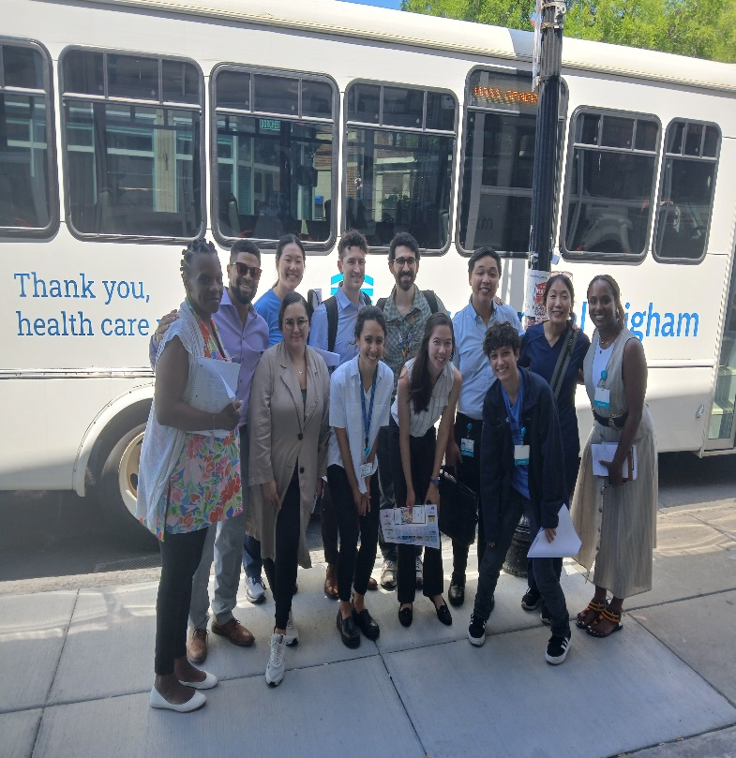
____________________________________________________

Social Outings
A Sweet Treat for a Good Cause: (The Jimmy Fund)
How We Scooped Up Some Fun at the Scooper Bowl
Nothing beats a bowl of ice cream on a hot summer day, especially when it's for a great cause. That's why our clubhouse members decided to take a break from our usual work-ordered day schedule and head to the Scooper Bowl, the nation's largest all-you-can-eat ice cream festival.

One of the most popular events of the summer was the Scooper Bowl, a three-day ice cream festival that raised money for cancer research. Our clubhouse members enjoyed sampling different flavors of ice cream from local and national vendors, while listening to live music and browsing the stalls of other attractions. Some of us even got temporary tattoos from a talented artist who donated her proceeds to the cause. The Scooper Bowl took place on June 6th at Boston City Hall Plaza, and it was a fun and delicious way to support a noble mission. We highly recommend it to anyone who loves ice cream and wants to make a difference in the world.

Social Outings
TOB Outing at Revere Beach & The Sand Sculpting Festival

Another exciting event we had at TOB was our outing to Revere Beach to view the Sandcastle Competition on July 20, 2024. This annual event showcases the amazing talent and creativity of local and international sand sculptors who create stunning works of art using only sand and water. The theme of this year's competition was "Celebrate the Future" and we saw some incredible sculptures depicting futuristic scenes and characters, as well as some inspired by popular movies, books, and games.
We had a great time admiring the sculptures and taking pictures of them. We also learned about the history and significance of Revere Beach, which is the oldest public beach in the United States and a landmark of Massachusetts. We enjoyed the sunny weather and the breeze from the ocean, as well as the lively atmosphere of the beach. We sat to eat lunch that TOB provided and some of us also indulged in food and drinks from the food truck vendors. We ate as a group on the grass and at picnic tables along the side of the beach and chatted about our favorite sculptures and other topics. We also met some other visitors and shared our stories and experiences with them. It was a fun and relaxing day that made us appreciate the beauty and diversity of our
Community.

We are happy to share some of the pictures that we took at the outing on our social media, newsletter, and slide show. You can also check out the official website of the Revere Beach Sand Sculpting Festival to learn more about the event and the artists. We hope you will join us for our next outing to Canobie Lake and discover new places and activities with us. TOB is always open to your suggestions and feedback, so feel free to contact us anytime. Thank you for being part of our TOB family and see you soon!

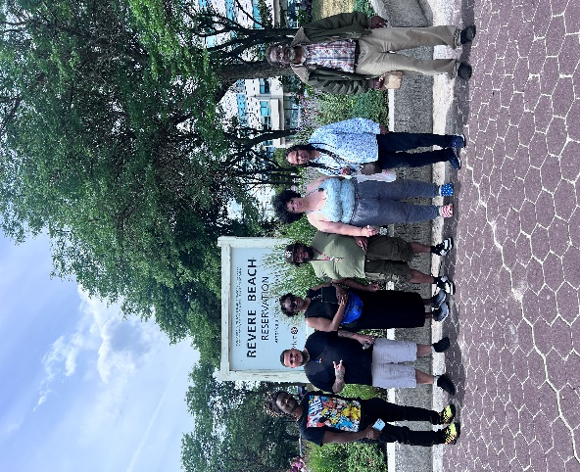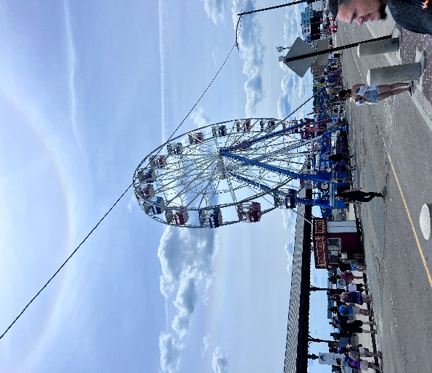
Social Outings (Cont’d)
TOB Outing at Revere Beach & The Sand Sculpting Festival
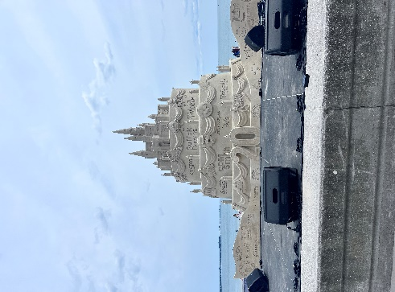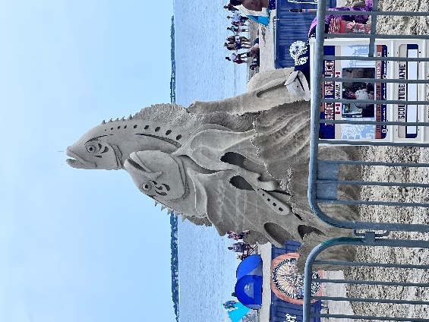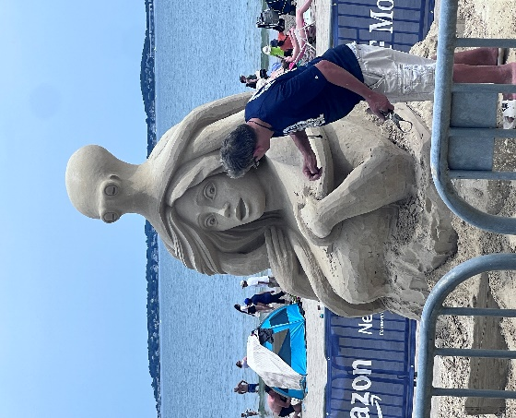
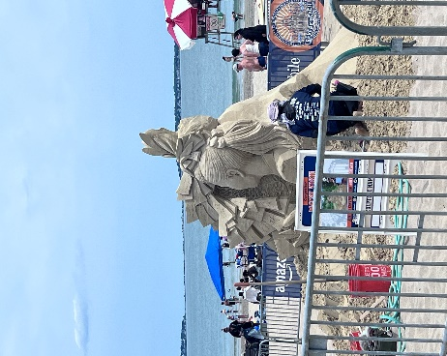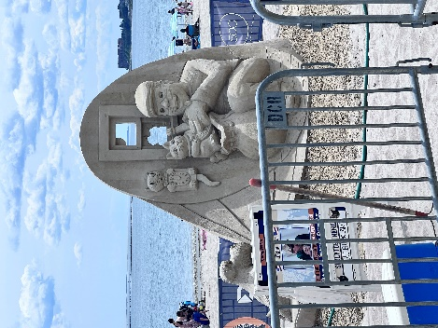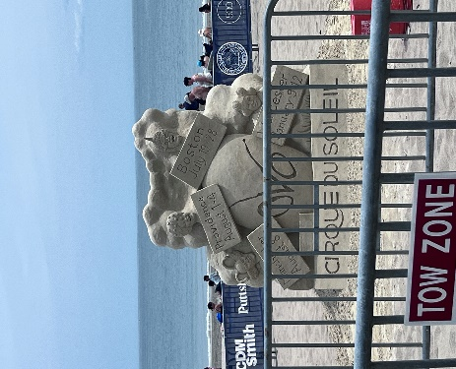
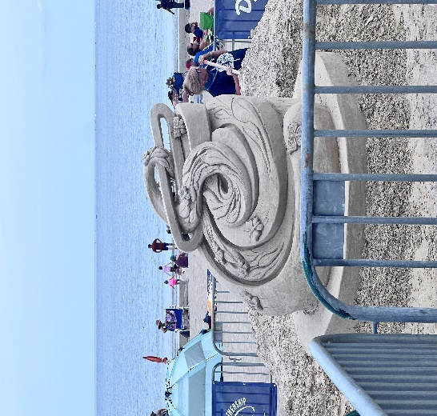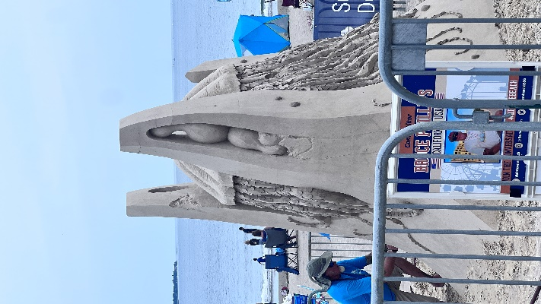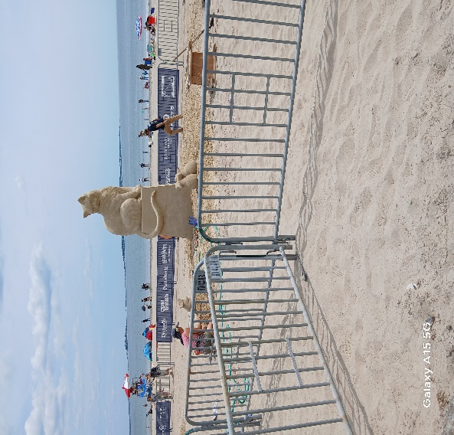

Social Outings (Cont’d)
TOB Outing at Revere Beach & The Sand Sculpting Festival
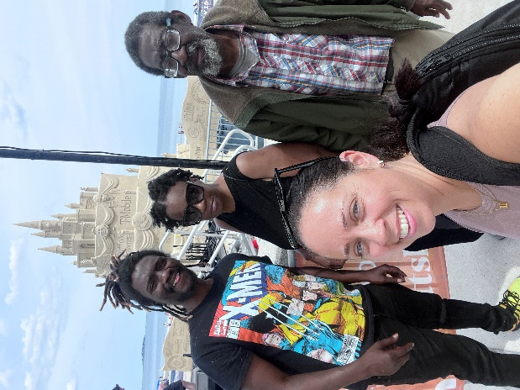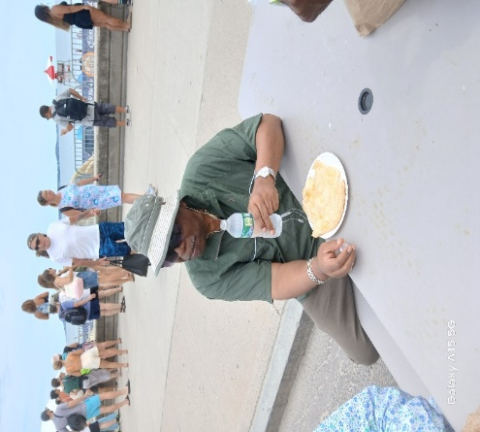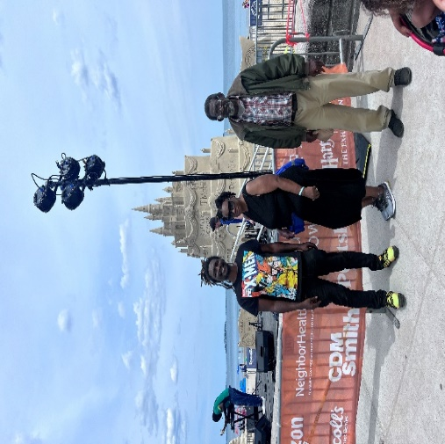
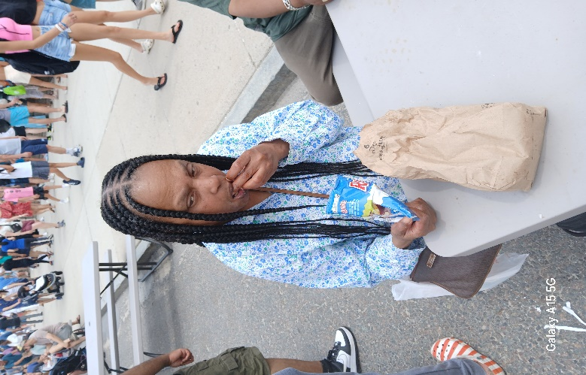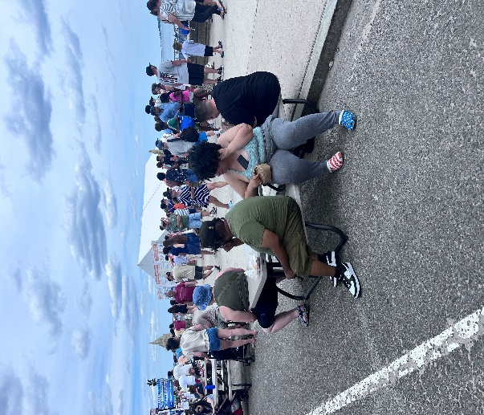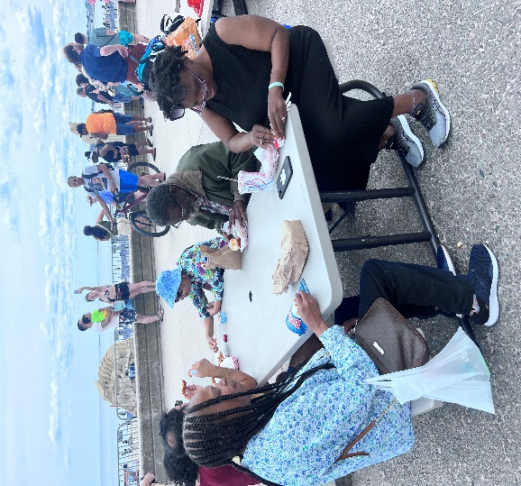
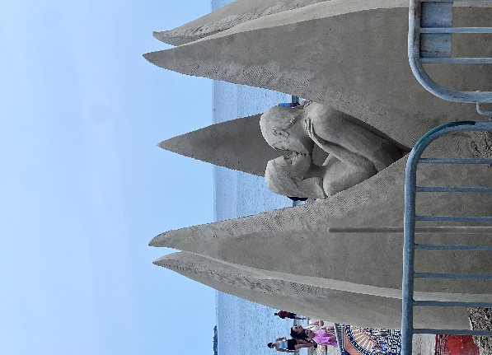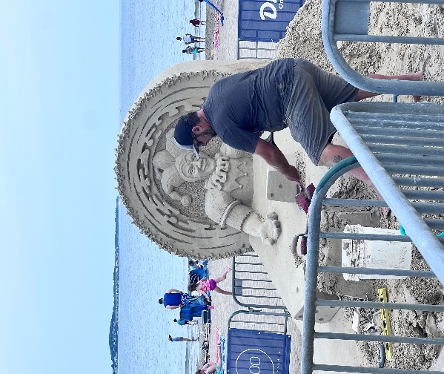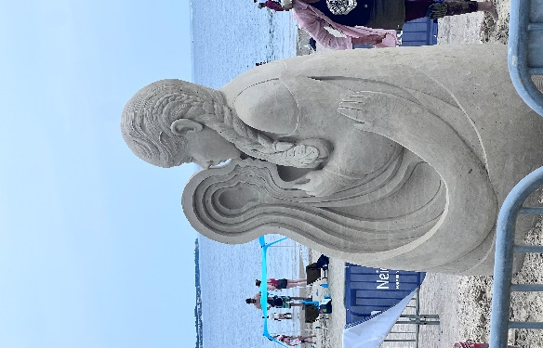



Check out our new webpage!
We will be posting upcoming clubhouse events.
Find us by searching “Transitions of Boston
Clubhouse” or transitionsofboston.org
All clubhouse news, information, outings, lunches, and so much more will be updated on a daily basis.

Contact Us
Give us a call for more information about our services.
1500 Dorchester Ave.
Dorchester, MA 02122
Phone: 617-379-5661
Transitionsofboston1@gmail.com

NONPROFT ORG
U.S. POSTAGE PAID
BOSTON, MA
PERMIT NO. 55903

Bay Cove Human Services
Transitions of Boston Clubhouse
66 Canal St
Boston, MA 02114

