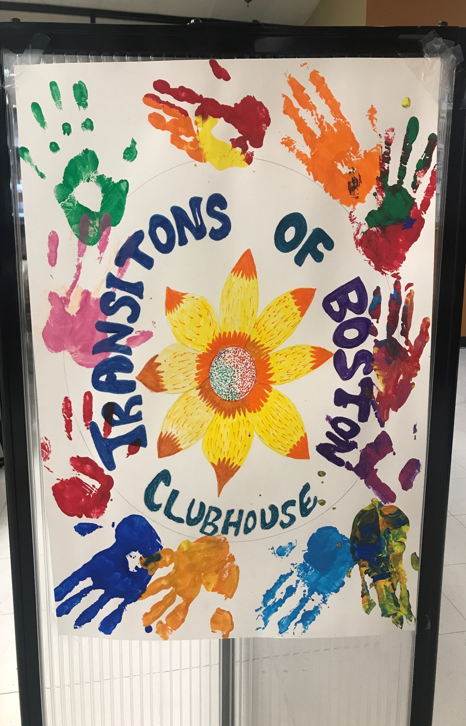
VOLUME #19 June & July 2025
Newsletter
TRANSITIONS OF BOSTON CLUBHOUSE
1500 Dorchester Ave.
Dorchester, MA 02122

Phone: 617-379-5661
Fax: 617-541-6817
Website: Transitionsofboston.com
Facebook: @TOBClubhouse

In This Issue:
- Cover Page ………… 1
- Our Editor’s Page …………………....2 & 3
- Employment & Education ………………….….... 4
- Membership & Social ………………….… 5 - 16
- Food Service Unit… 17 - 18
- Members Spotlight
…………….……. 19 - 20
- Happy Birthdays ……
…………..…………… 21
- Contact us ……..….. 22


Transitions of Boston Newsletter
“Transitions of Boston Clubhouse guarantees…
A right to a place to come.
A right to meaningful work.
A right”


Editorial- June & July 2025 Edition

Title: “Summer Highlights at TOB”
Editorial: Summer arrived with a splash at TOB Clubhouse, and June and July were full of sunshine, smiles, and sweet memories. From enjoying ice cream at Boston’s famous Scooper Bowl to admiring the incredible sand sculptures at Revere Beach, members embraced every chance to get outside and enjoy the season together.
One of the biggest highlights? Our trip to Canobie Lake Park! Members enjoyed thrilling rides, tasty treats, and plenty of laughter. It was a day of pure fun and friendship, one we’ll be talking about for a long time. We also kicked off weekly community walks again, our favorite way to stay active and explore local beaches. Whether it was a breezy stroll or a full afternoon of connection, these outings reminded us how good it feels to move, reflect, and soak up the summer sun.

In June, members traveled to Webster House for a special Father’s Day celebration. It was a warm and welcoming gathering filled with appreciation, shared stories, and good food. Connecting with another Clubhouse made the day even more meaningful, and we’re grateful for the hospitality and joy shared. Birthday celebrations were extra joyful this time around! June and July birthday stars were celebrated with birthday cake served alongside with the Recipe of the Month meal. Another highlight was the Transitions of Boston Open House, where members proudly represented our Clubhouse and connected with others in the wider community. It was a chance to share our stories and talents, and feel the power of belonging.

In this issue of the TOB Chronicle, you’ll find: Scooper Bowl reflections and photos. Webster House – Father’s Day Celebration. A recap of Transitions of Boston Clubhouse Open House. Canobie Lake Park highlights. Revere Beach Sand Sculpture snapshots and Members Birthday shout-outs for June and July and the featured Recipe of the Month Meals. Upcoming events and ways to get involved

Valerie Lucien,
Editor

Employment & Education Unit
Working In Units

We have made some changes and updated to our groups in our Employment and Education Units. In addition to the new changes, we have two new great Fulltime Staff, Kemisha and Julia, two new Per-diem Staff - Alessio and Fred as well as two new Interns from UMass Boston - Shawn and Joshua, they are all raring to assist and support our Members in their search for Employment or continuing their Education.

Some of our new addition to our Groups are Advance Computer Training, Diversity Training, Study Groups, and Essential Skills. As well as the continuing of Job Club and the support from Mass-Ability (MRC). In these groups we have open discussions about interviews, good and bad work habits. Updating resumes and references.
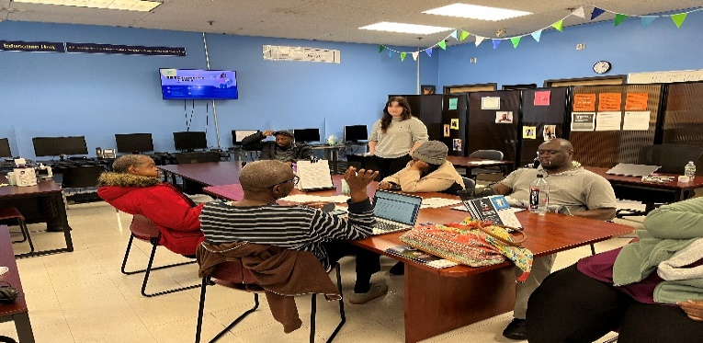
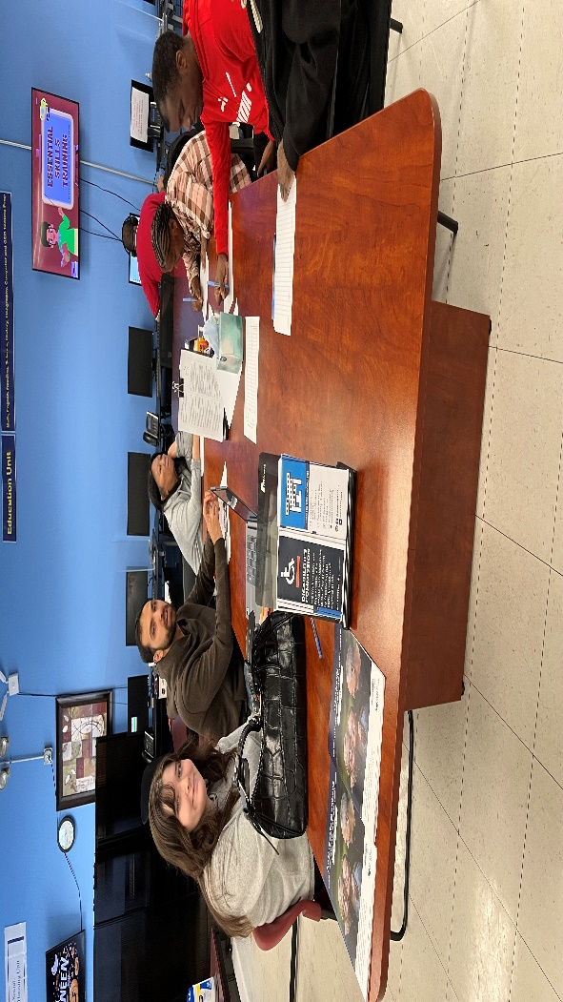
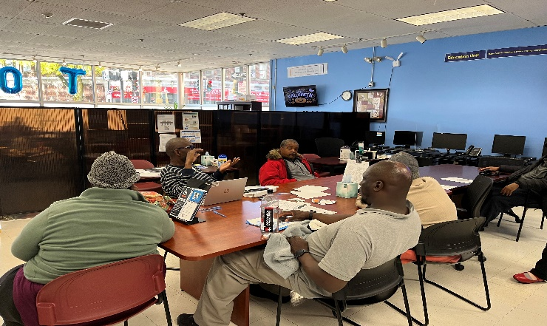

Membership & Social Unit

Scooper Bowl Bliss: A Sweet Start to Summer:
TOB Members & Staff Celebrate Sunshine, Ice Cream, and Togetherness
On June 4th, the TOB Clubhouse crew kicked off summer in the most delicious way possible with a trip to Boston’s legendary Scooper Bowl. Held annually at City Hall Plaza, this all-can-you-eat ice cream extravaganza brought together dozens of top brands, endless flavors, and a whole lot of joy. Under clear blue skies and warm sunshine, members and staff strolled through the festival, sampling scoops of every kind from classic vanilla to bold cookie dough, fruity sorbets to dairy-free delights. Laughter echoed between bites, and sticky fingers were a small price to pay for the sweet memories made.
Highlights from the Day:
Staff & Member Moments: Whether teaming up to try every booth or cooling off in the shade with a scoop in a cup, the camaraderie was contagious. Weather Wonders: The perfect mix of sun and breeze made the outing feel like a postcard moment.
Photo collage: Smiles and scoops-our collage captures the joy of the day. (Optional, insert collage with captions like “Double scoop smiles”, “ Brain freeze buddies,” and “Team TOB takes on the bowl”)
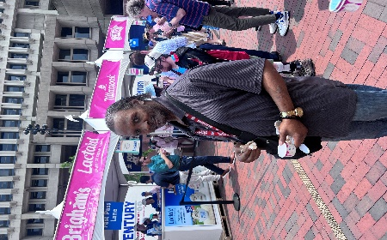
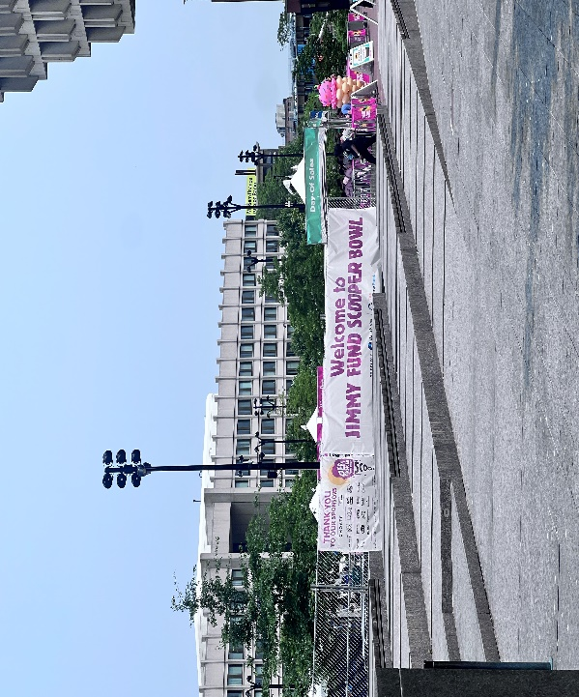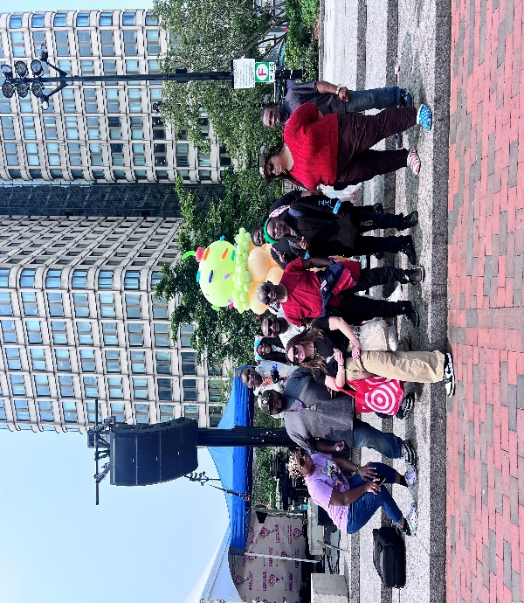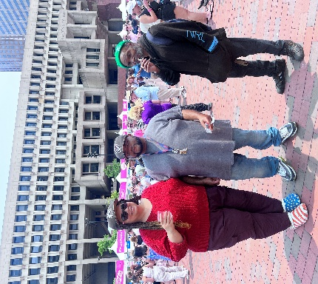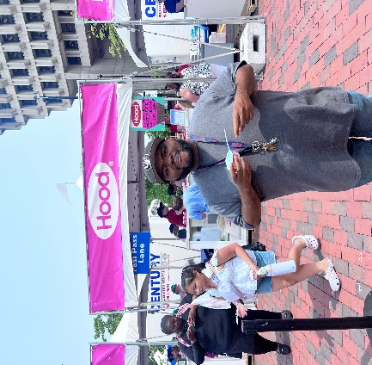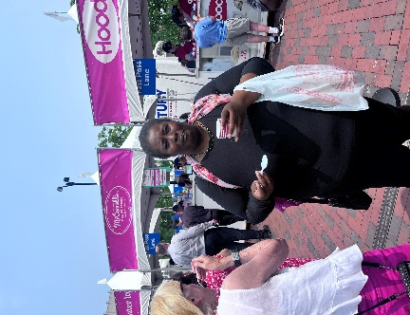

Transitions of Boston Open House – June 11, 2025:
A Celebration of Talent, Teamwork, and TOB Spirit: On June 11th, the Transitions of Boston Clubhouse opened its doors to the community for a vibrant and unforgettable Open House. The event was a true reflection of TOB’s mission: to uplift, empower, and connect through creativity and collaboration. From the planning stages to the final applause, TOB members and staff worked together to create a well-organized, welcoming experience. Special thanks to everyone who helped prepare, perform, and represent TOB with heart and excellence.
A Showcase of Talents & Gifts:
TOB member Valerie Lucien served as the event’s MC, opening the stage with a warm and powerful welcome that set the tone for the afternoon. The Talent & Gifts Showcase featured a mix of original and well-loved songs, heartfelt poetry, and music videos, some written and produced by the members themselves, and others performed with passion and pride. Each piece reflected the creativity, courage, and spirit of our Clubhouse community.
Clubhouse Unit Tours:
Guests were invited to tour each Clubhouse unit, guided by members who shared how each area operates and supports personal growth. From employment and education to wellness and outreach, the tours offered a meaningful glimpse into the daily life and purpose of TOB.
Lunch & Connection:
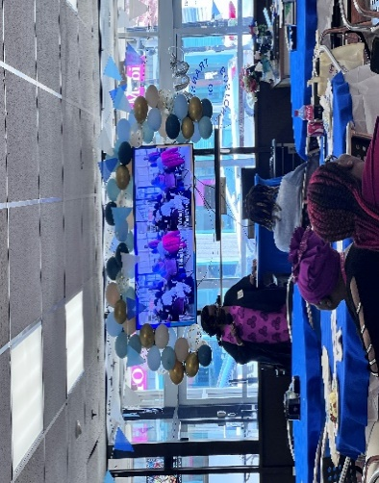
Attendees enjoyed a sit-down lunch with sandwich wraps, chips, dessert, and drinks, creating a space for conversation, connection, and celebration.
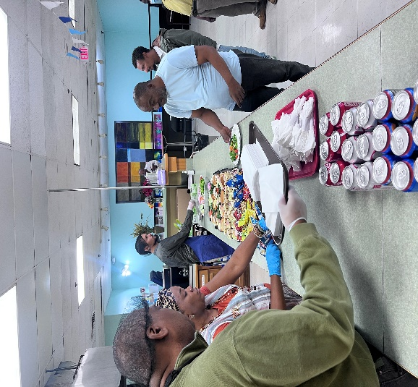
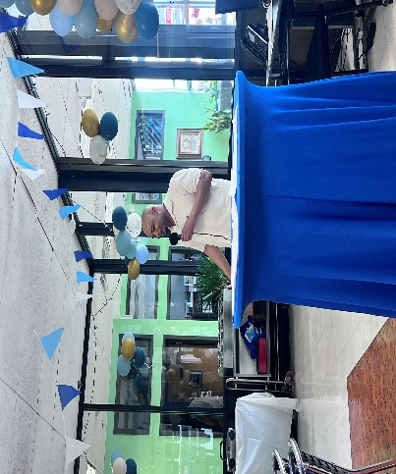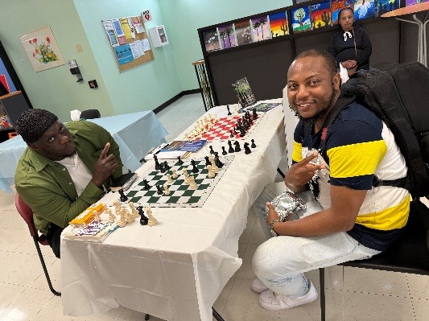
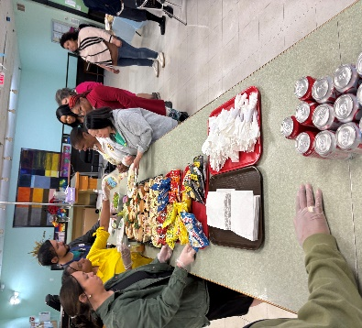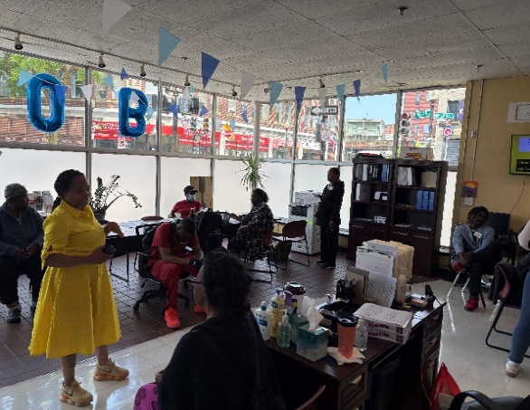

Bay Cove T-Shirt Design Contest Awards for the 2025 NAMI Walk:
During the Open House, Fedjie Charles, assistant to Bay Cove Director Lisa Morrishanti, honored TOB members who participated in the NAMI Walk T-Shirt Design Contest. Each participant including Sue and Elliott received a Certificate of Participation and a gift card as a token of appreciation for their creativity and contribution.
Two finalists’ winners, Valerie Lucien and Tina Smith were awarded Certificates of Achievement and $100 gift cards in recognition of their standout designs. Their artwork was later commemorated with a custom shadow boxes, presented at a separate date following the Open House. These keepsakes now serve as lasting tributes to their talent and impact. Congratulations to all who entered and represented Bay Cove with pride!

Shadow Box Tribute: Stronger Together- Mental Health For All (TO BE ACCOMPANIED WITH MY PHOTO WITH SHADOW BOX) Valerie Lucien- NAMI Walk T-Shirt Design Finalist. I’m deeply honored to receive this shadow box in recognition of my design for the NAMI Walk T-shirt Contest. It’s more than a keepsake, it’s a celebration of unity, healing, and the power of creative expression.

My design, titled “Stronger Together: Mental Health For All,” is featured on the back of the t-shirt as a heart-shaped puzzle. Each puzzle piece contains a word or image that reflects values we hold close in our mental health journey: Hope, Inclusivity, Well-Being, Support, Togetherness, Empathy, Resilience, Awareness, and Caring. The puzzle also includes meaningful illustrations - a plant stem with leaves symbolizing growth, a light bulb for ideas and insight, a heart for compassion, a smiley face for joy, and two hands joining at the fingertips to represent unity and connection. The design is colored in calming shades of blue and green to evoke peace, healing, and strength. Thank you to Bay Cove, TOB Clubhouse, and everyone who supported this vision. This shadow box reminds me that when we come together with compassion and creativity, we build something truly powerful.

With gratitude and pride,
Valerie Lucien
TOB Member and Design Finalist

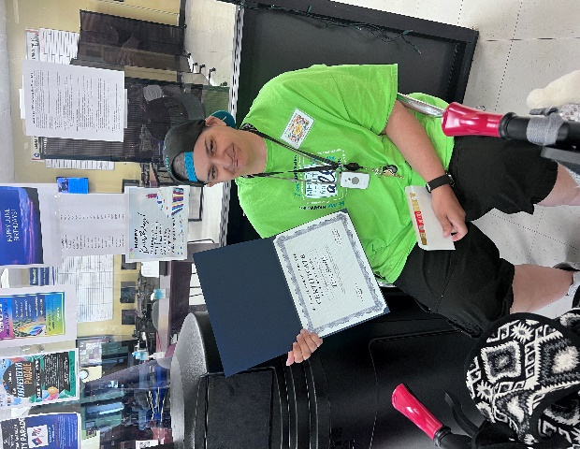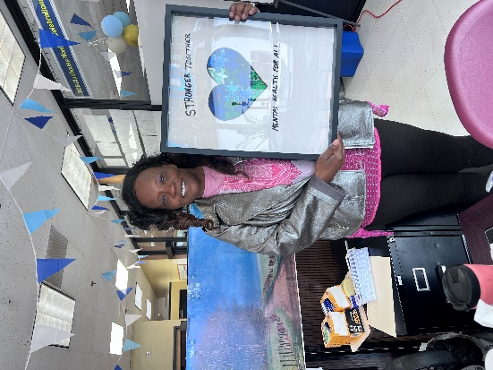

A Call to the Community:
The Open House wasn’t just a celebration; it was an invitation. TOB is more than a building; it’s a mission-driven community where individuals grow, heal, and thrive together. Whether you’re an artist, a mentor, a neighbor, or someone seeking connection, there’s a place for you here. We welcome new members, volunteers, and partners to join us in shaping a vibrant future. Come share your talents, learn new skills, and be part of a movement that uplifts and empowers.

Gratitude & Looking Ahead:
The Open House was a true reflection of what TOB stands for: empowerment, inclusion, and shared purpose. We thank every guest who attended, every member who participated, and every staff member who supported the event. Your presence made it meaningful and your talents made it unforgettable. We’re already looking to what next year’s Open House will bring. Until then, enjoy the collage of photos capturing the joy, unity, and brilliance of this special day.

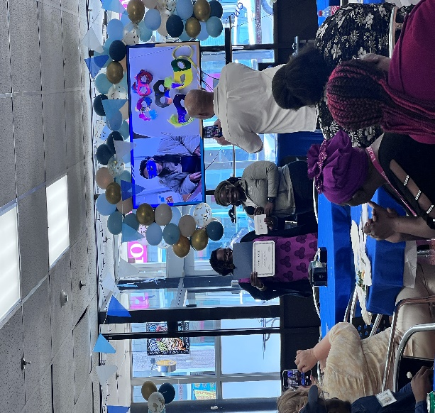
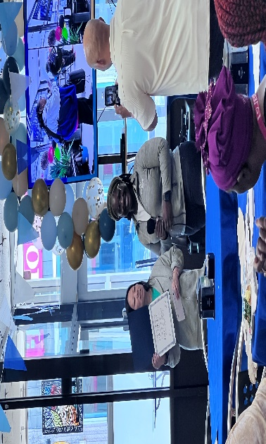
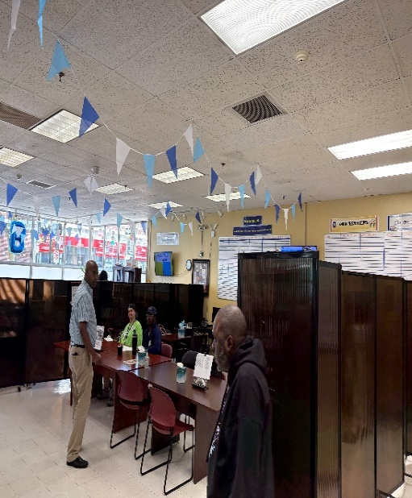

Father’s Day Celebration with Webster House:
In June, TOB members and staff traveled to Webster House for a heartfelt Father’s Day Celebration - and what a day it was! From the moment we arrived, we were warmly welcomed and embraced like family. The event was a beautiful blend of storytelling, laughter, and connection between two Clubhouses.

Members shared touching tributes to the fathers and male role models who shaped their lives. Dante Deans and Eugenie Laurent moved the room with personal stories that honored strength, love, and legacy. Whether it was a dad, uncle, mentor, or one of those iconic figures we all admire - everyone had someone to celebrate. The mingling was lively and full of joy. Conversations flowed, friendships blossomed, and the social energy was electric. A spirited round of Family Feud added a playful twist to the Father’s Day Celebration at Webster House, with Valerie, Eugenie, and Tina emerging as TOB champs joining other winners in a lively showcase of quick thinking and teamwork. And yes - dad jokes were absolutely part of the celebration, bringing groans, giggles, and eye-rolls in equal measure. A few favorites:

“What did the father buffalo say to his son when he left for college? Bison”
“Why did the dad bring a ladder to the bar? Because he heard the drinks were on the house.” “What do you call someone who tells dad jokes but isn’t a dad? A faux pa.”
“I used to hate facial hair...but then it grew on me.”

The food was nothing short of mouthwatering: crispy fried chicken, savory rice and beans, creamy macaroni and cheese, golden cornbread, fresh salad, perfectly fried fish, and a decadent carrot cake for dessert. Drinks flowed, laughter echoed, and bellies were full. Goodie bags were handed out as tokens of appreciation filled with thoughtful items to honor the occasion and send members off with something meaningful as they continued their Father’s Day celebrations. Whether celebrating a dad, uncle, grandfather, mentor, or one of those everyday heroes we look up to, the gesture reminded us that appreciation comes in many forms.

TOB members brought the energy, the wit, and the heart proving once again that when we come together, we make memories worth smiling about. We extend a heartfelt thank you to Webster House for hosting us with such generosity and spirit. Events like these remind us of the power of Clubhouse connection where community isn’t just a word,
it’s a feeling. When we come together, we don’t just celebrate holidays, we celebrate each other.
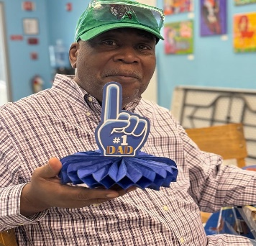
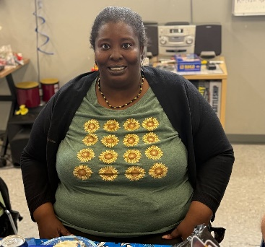
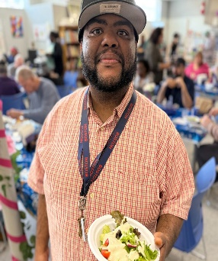
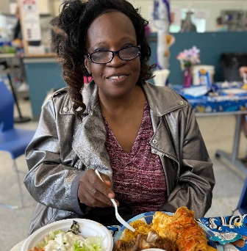
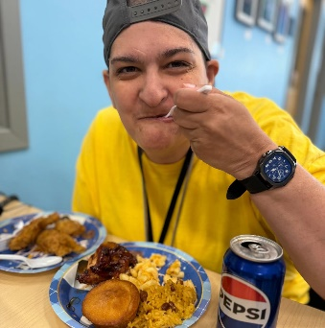

Juneteenth Celebration at TOB- June 18^{th:}
Honoring Freedom, Culture, and Community; Through Food, Music, and Reflection
On June 18th, the TOB Clubhouse came together for a powerful and joyful celebration of Juneteenth, a day that honors the end of slavery in the United States and the ongoing journey toward justice and equality. Members and staff gathered to reflect, learn, and uplift one another through shared stories, soulful music, and delicious food.

A Feast of Culture & Comfort:
The celebration featured a mouthwatering spread of traditional favorites, including macaroni and cheese, collard greens, rice and beans, meat loaf, fried chicken, and other savory delights. Drinks and desserts rounded out the meal, creating a warm and welcoming atmosphere and invited connection and conversation.

Learning Together:
The celebration opened with a powerful rendition of “Lift Every Voice and Sing,” often referred as the Black National Anthem. Sung by members and staff together, the anthem set a tone of reverence and unity, honoring the resilience and hope that Juneteenth represents. As part of the program, members learned about the history of Juneteenth and its significance. Juneteenth marks June 19, 1865, the day enslaved people in Galveston, Texas were finally informed of their freedom, more than two years after the Emancipation Proclamation. In 2021, Juneteenth was officially recognized as a Federal Holiday, signed into law on June 17, 2021.
This moment of learning was woven into the celebration, reminding us of the importance of honoring the past while building a more inclusive future.

Performances & Poetry:
The event was hosted by Dante Deans, who served as MC with warmth and energy, opening the stage for a moving showcase of poetry readings and songs. Members shared both original works and performances of favorite songs by well-known artists, celebrating Black culture and resilience through music and spoken word. Staff joined in the singing, creating a beautiful harmony of voices and hearts. Original poetry written by members reflected themes of freedom, strength, and unity, each piece a testament to the creativity and courage within our Clubhouse.

Gratitude & Community Effort:
A heartfelt thank you goes out to everyone who contributed, from those who helped with the setup and kitchen prep, to those who cleaned up and supported the planning behind the scenes. Your efforts made the day meaningful and memorable.

Photo Reflections:
This issue included photos from the celebration – smiles around the table, snapshots of performances, and candid moments of joy and reflection. These TOB images capture the spirit of Juneteenth at TOB: proud, united, and full of heart.

Juneteenth Celebration (Cont’d) – 2025, June 18th:
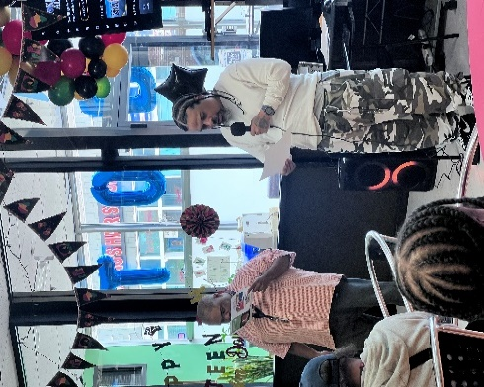
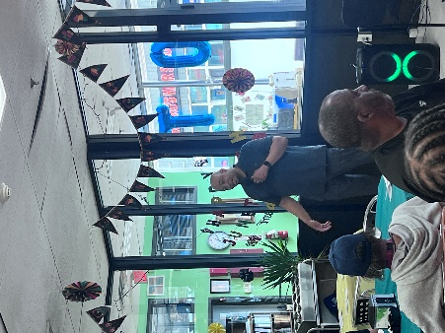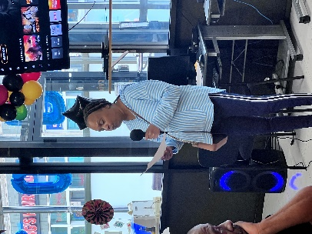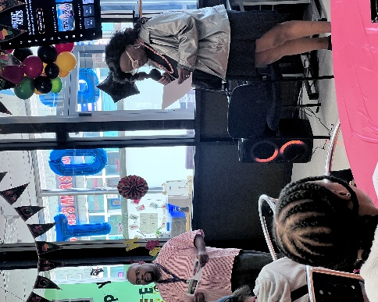
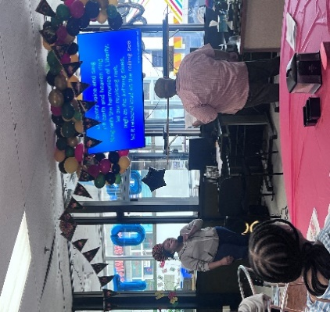
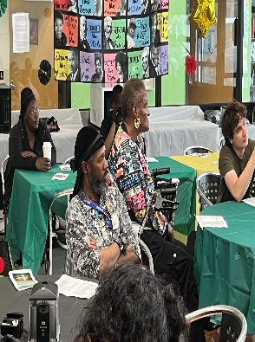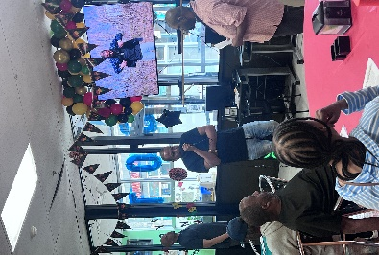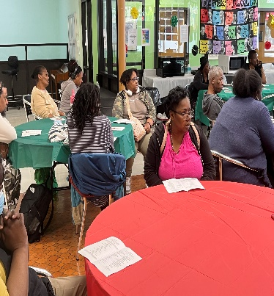
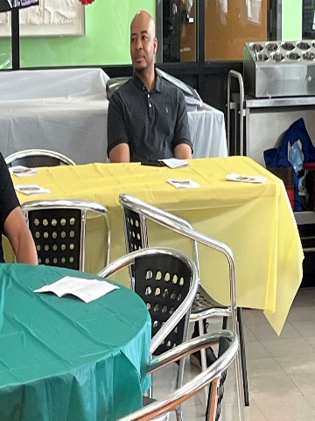
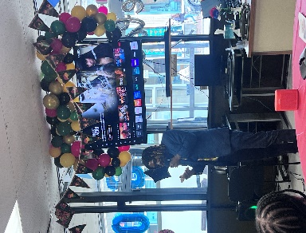
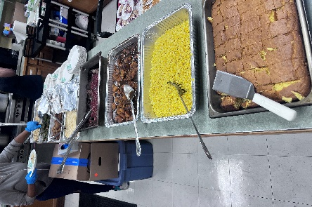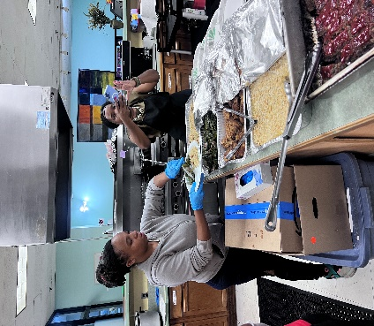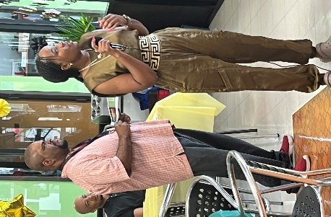
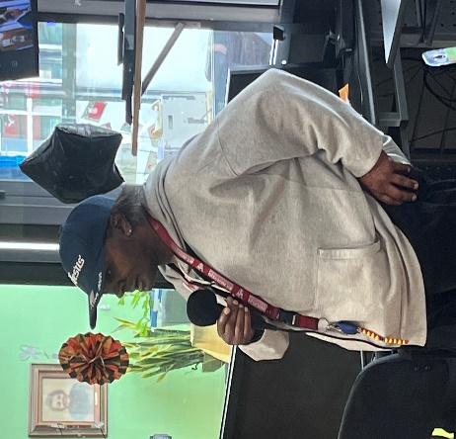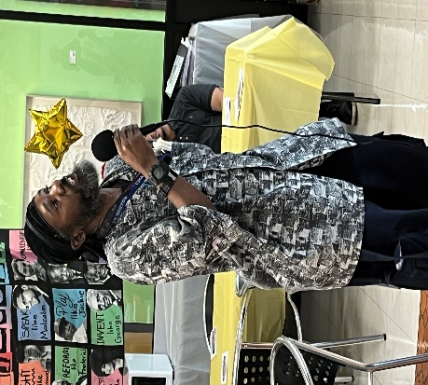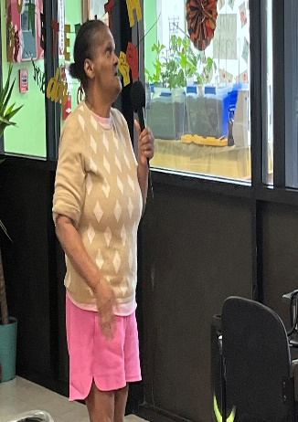

Revere Beach Sand Sculpture Festival- July 26, 2025:
A Day of Sun, Sculptures, and Summer Treats:
On July 26th, TOB Clubhouse members and staff headed to Revere Beach for a sun-soaked social outing that blended art, adventure, and community connection. The annual Revere Beach Sand Sculpture Festival was in full swing, drawing crowds from across the region to admire breathtaking creations carved from the shore itself.

Sculptures That Stole the Show:
Members strolled along the boardwalk with the ocean breeze at their backs, pausing to admire towering sandcastles and intricate designs crafted by world-class sculptors, from mythical creatures to historical tributes, each sculpture told a story, reminding us of the creativity and skill that transforms sand into spectacle.
The Sand Sculpture Festival has been a beloved summer tradition since 2004, making Revere Beach a seasonal destination for art lovers and beachgoers alike. Each year, artists from around the globe compete and collaborate, turning into a temporary gallery of wonder.

Weather & Vibes:
The day was sunny and breezy, with just the right mix of warmth and wind to keep spirits high. Members enjoyed the fresh air, scenic views, and the joy of walking together in a relaxed, open setting. Whether snapping photos or simply soaking in the moment, the outing offered a perfect blend of movement and mindfulness.

Booths & Free Samples:
While exploring the festival, members and staff scoped out booths offering free samples of refreshing water, energy drinks, natural sodas, and a flavorful lineup of hot sauce, buffalo sauce, and Wing ‘n Dip. The variety added a fun, interactive twist to the calm, with plenty of taste-tasting and laughter along the way.

Food Truck Favorites:
Lunch was a highlight, with members enjoying delicious bites from local food trucks. Popular picks included: Authentic beef tacos with favorite toppings like cilantro, onions, and salsa Churros- the cinnamon-sugar Mexican treat that had some members smiling
Rum cake- a rich, flavorful dessert that was brought home as a sweet taste of the day
Other savory and sweet delights that made the outing feel like a true summer feast

Photo Reflections:
This issue features snapshots from the outing. These photos capture the essence of TOB: curious, connected, and always celebrate the season together. Photos from the day highlight two memorable perspectives: Group moments at Revere Beach - members gathered on the lawn area, enjoying the summer atmosphere and each other’s company. Sand sculpture snapshots - captured as standalone works of art, allowing the intricate designs to shine without distraction.

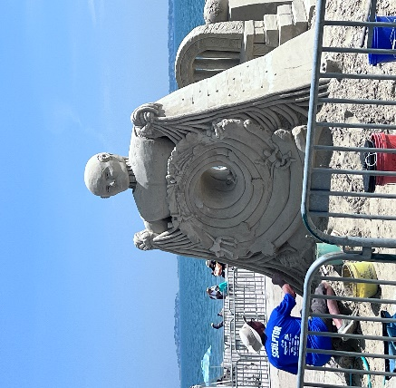
Revere Beach Sand Sculpture Festival:
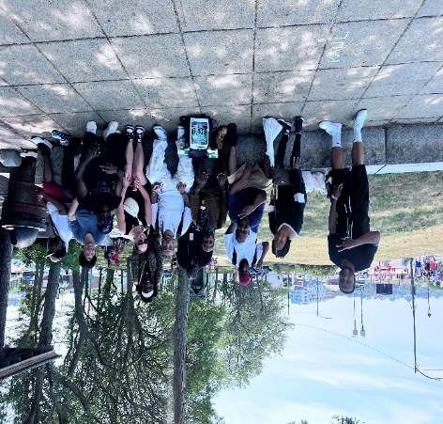
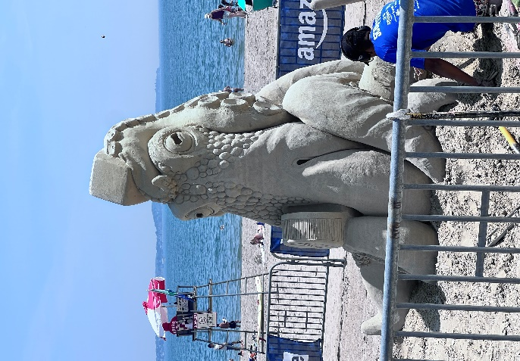
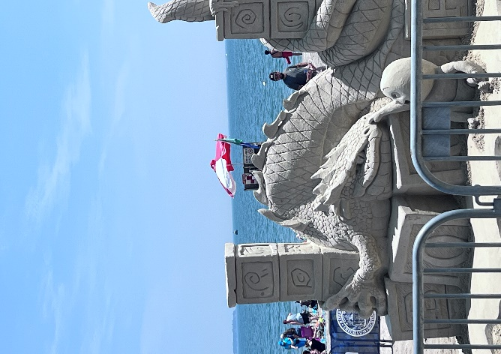
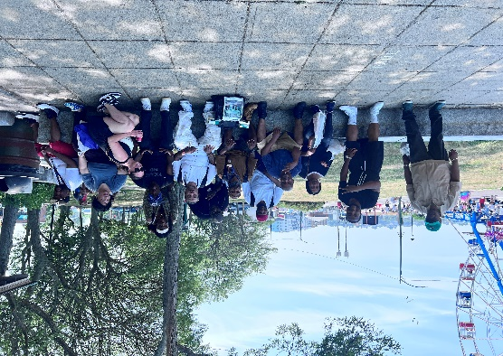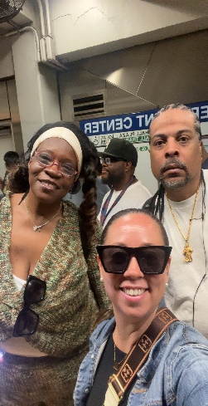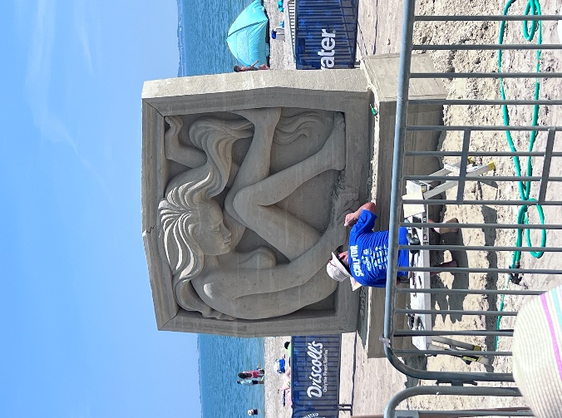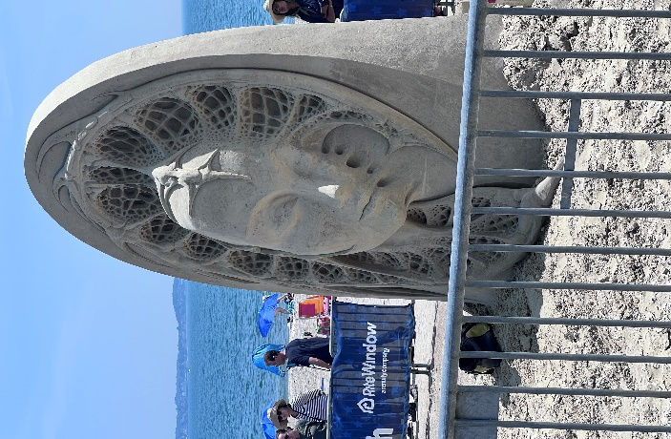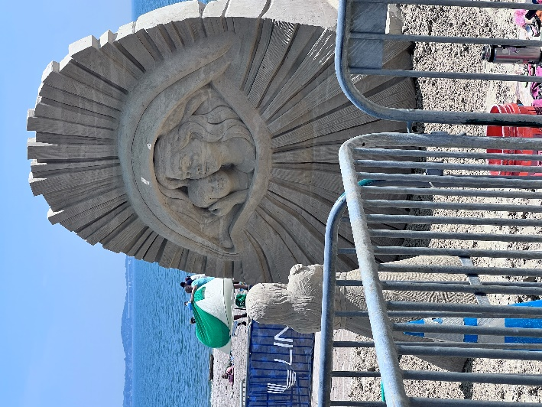

TOB Takes on Canobie Lake Park:
A Day of Thrills, Treats, and Togetherness:
This summer, TOB Clubhouse Members and Staff packed up their sunscreen and smiles for a full-day adventure at Canobie Lake Park, a beloved destination known for its exciting rides, classic carnival snacks, and scenic charm. The outing was more than just a trip; it was a celebration of friendship, freedom, and fun. From the moment we arrived, the energy was electric. Members split into small groups to explore the park at their own pace, with plenty of laughter echoing between roller coasters and snack stands.

Ride Highlights:
Among the most talked-about favorites were:
Starblazer- A high –flying thrill that had everyone cheering. Twist & Shout- Fast spins and big grins all around, Tea Cups-Whirling fun that brought out playful competition and giggles. Antique Carousel- A gentle classic that brought out nostalgic joy, Bumper Cars- A hit with members who love a little friendly collision. Sky Ride- A peaceful lift above the park with stunning views and quiet moments.

Whether braving the big rides or enjoying the scenic train tour around the lake, there was something for everyone. Some members opted for peaceful breaks by the water, while others strolled through the shaded garden paths or cheering each other on from the sidelines.

Tasty Treats & Park Eats:
No Clubhouse outing is complete without snacks and Canobie delivered! Members cooled off with lemonade drinks, munched on popcorn, and indulged in cotton candy and fried dough. The sweet and salty mix added to the festive atmosphere, with picnic tables turning into mini hubs of laughter and storytelling.

Relive the Magic:
As you read through the highlights, be sure to enjoy the photos from the day. They capture the laughter, the thrill, and the heart of our Clubhouse community in motion. Whether it’s a snapshot from the bumper cars or a fried dough smile, each image tells a story of joy, connection, and summer fun.
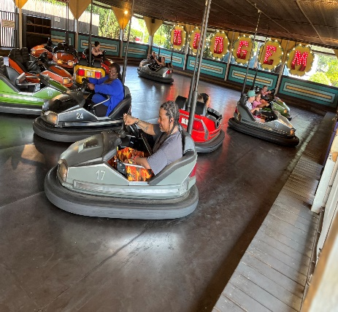
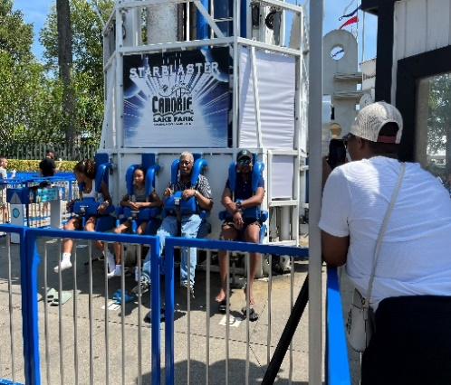
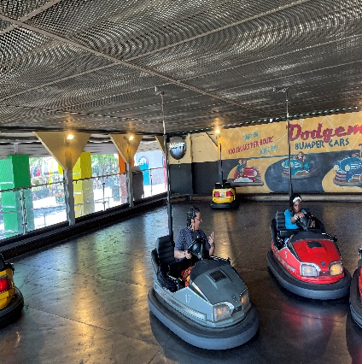

Canobie Lake (Cont’d) 2025:
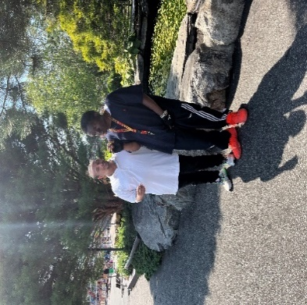
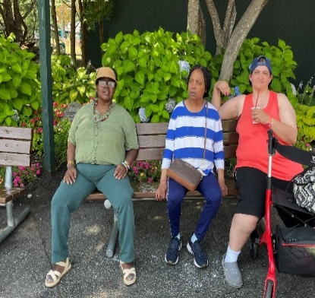

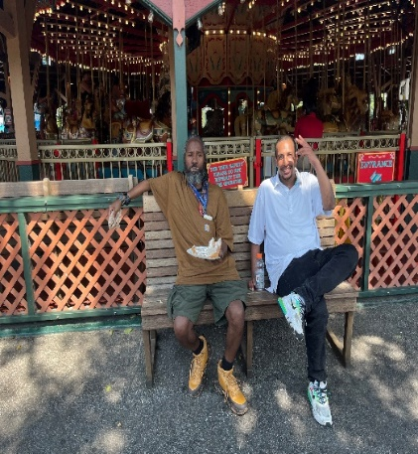
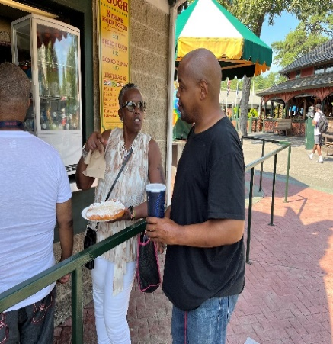
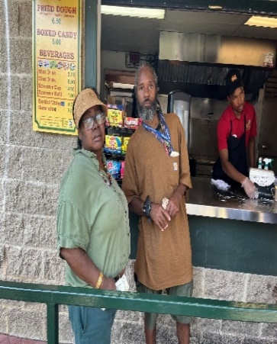
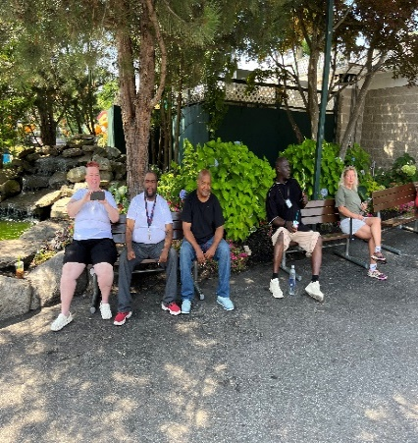
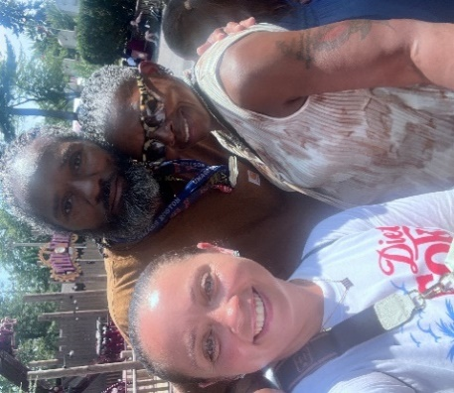
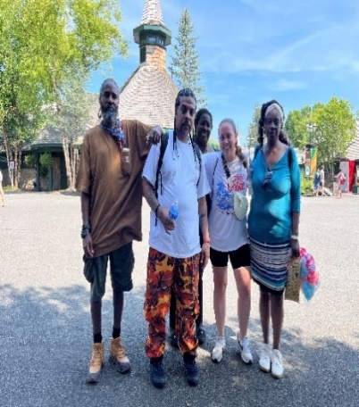
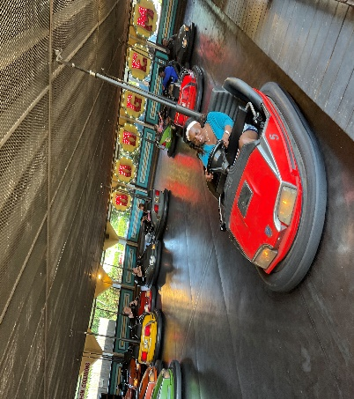
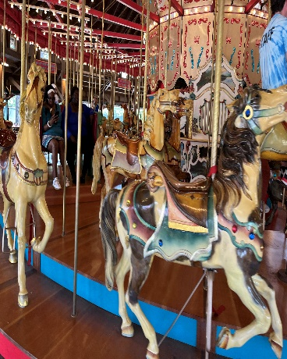

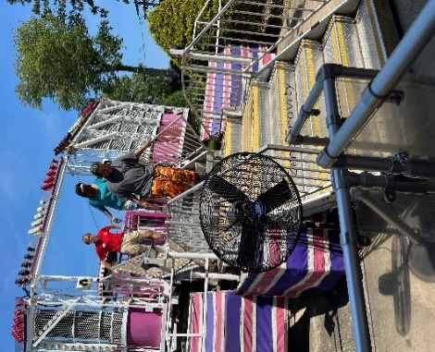
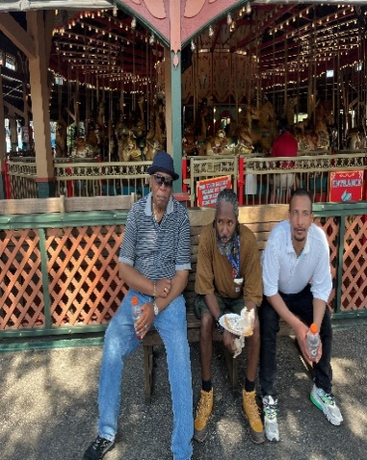
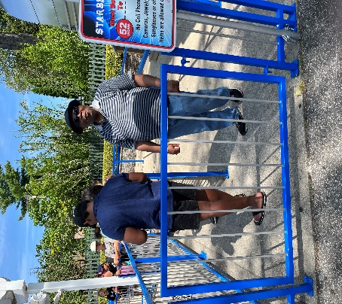
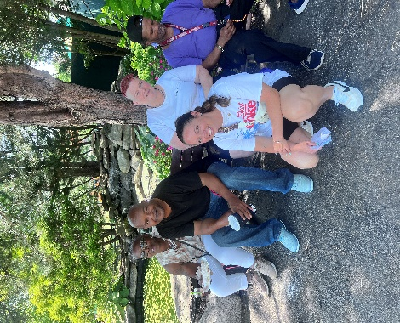

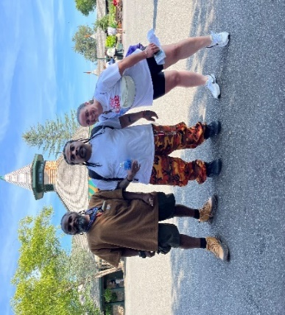
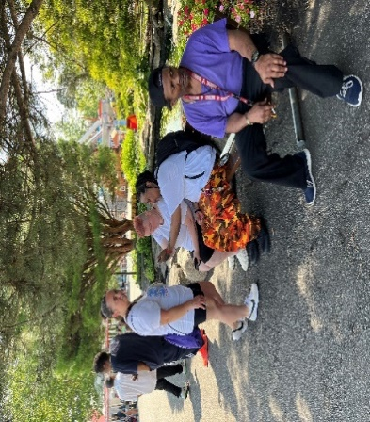
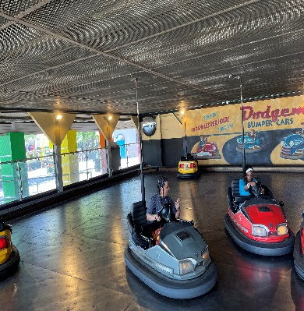
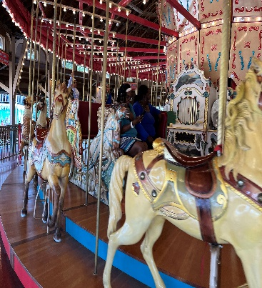
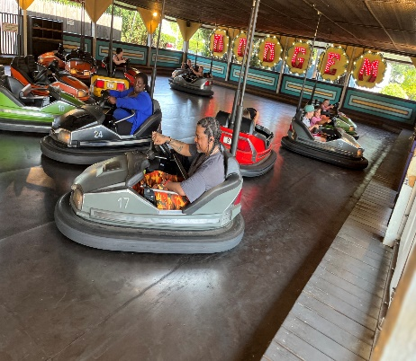
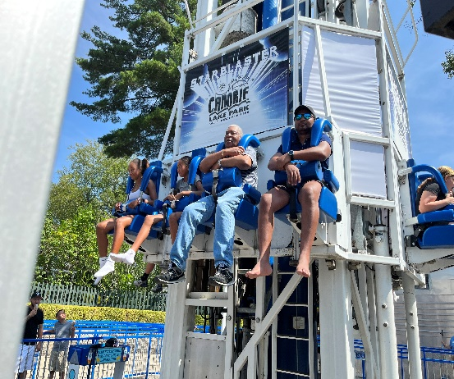

Stepping Into Summer: Community Walks Return
TOB Members Embrace Movement, Mindfulness, and Connection:
As the summer sun continues to shine, TOB Clubhouse Members have laced up their sneakers and stepped back into one of our favorite seasonal traditions - Community Walks. Organized through the Health & Wellness Unit, these weekly outings offer more than just fresh air: They are a chance to recharge, reconnect, and reflect.
So far, Members have enjoyed scenic strolls through Clubhouse neighborhood, peaceful walks along Malibu Beach, and refreshing visits to Castle Island, with more venues to come as inclusive, flexible, and uplifting - whether you’re in it for the exercise, the views, or the conversation.

Why Community Walks Matter:
Incorporating movement into our weekly rhythm supports both physical and mental well-being. Here’s how these walks benefit our Clubhouse community:
Boosts mood and reduces stress through gentle exercise and nature exposure,
encourages social connection in a relaxed, open-air setting, supports cardiovascular health and mobility for all fitness levels. Promotes mindfulness and reflection, especially when paired with quiet moments or guided breathing. Builds routine and structure, helping members stay engaged and motivated.

Whether walking in pairs or small groups, members often share stories, set goals, or simply enjoy the rhythm of the day. Staff walk alongside, offering encouragement and celebrating each step forward.

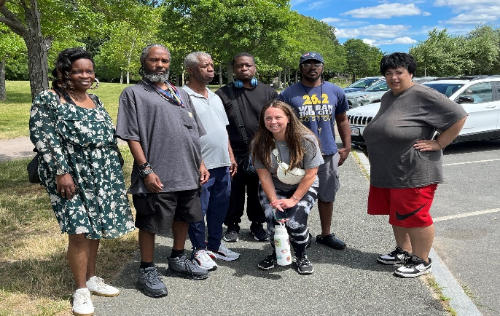
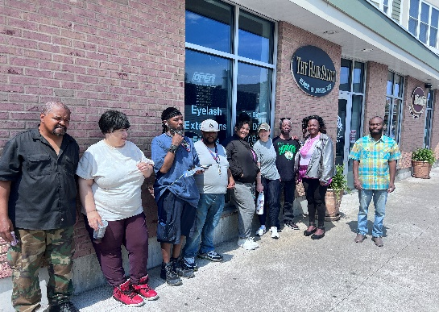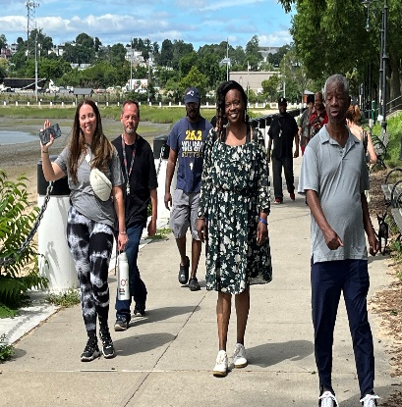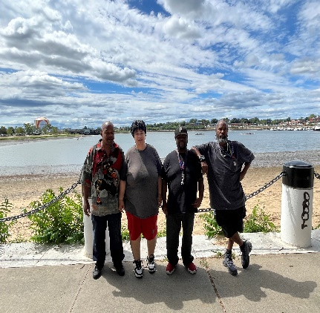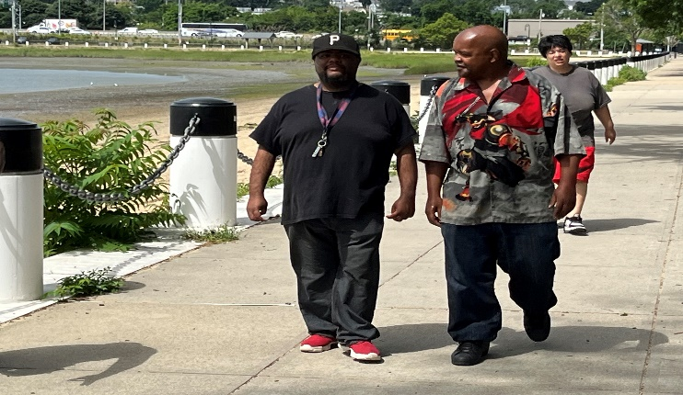

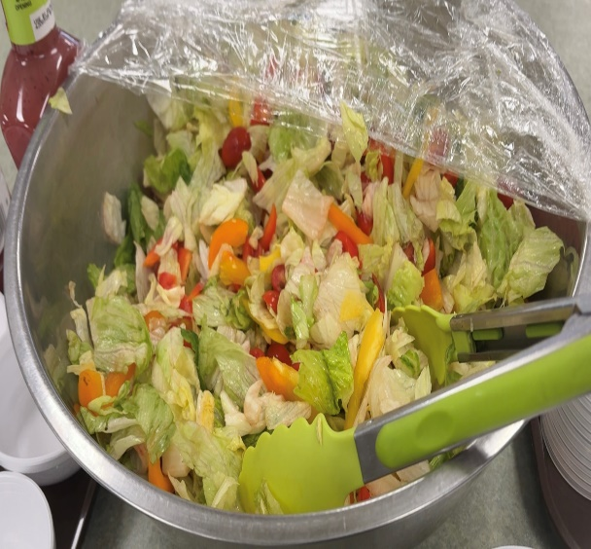
Food Service Unit
June: Monthly Receipt – Turkey Burgers W/Sweet-potato Fries & Salad and Birthday Celebration:
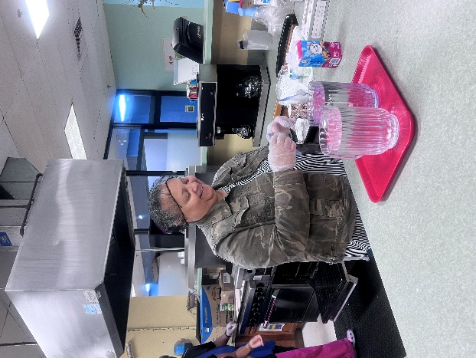
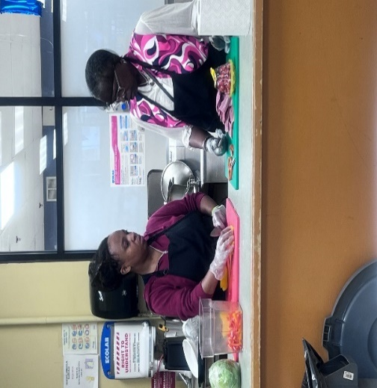
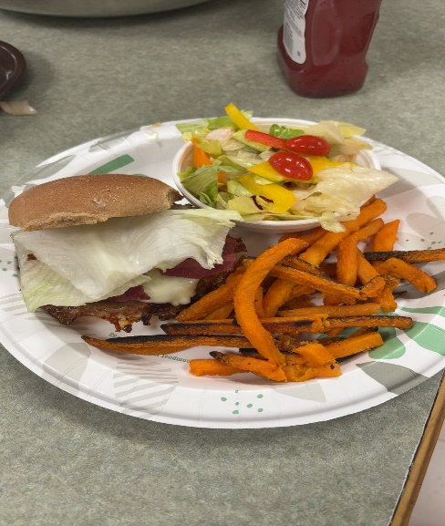
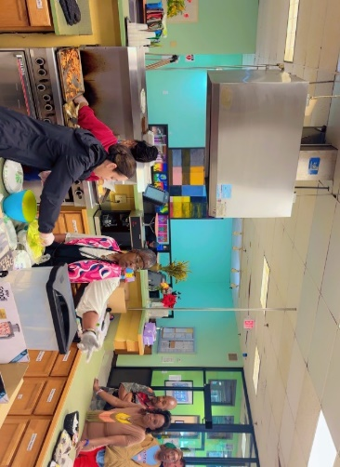
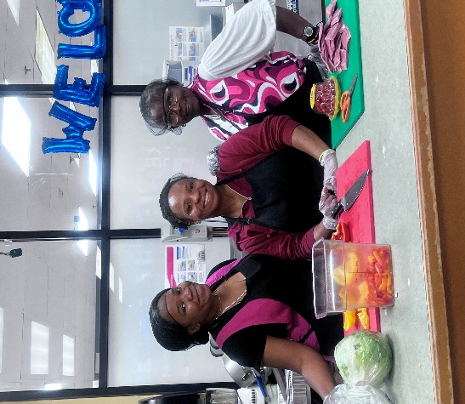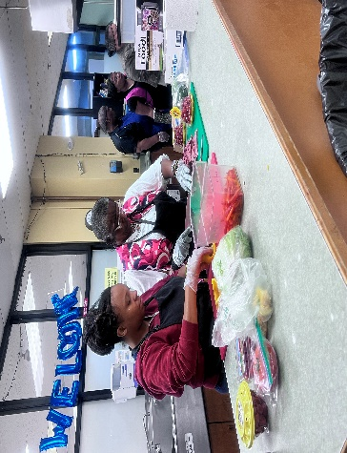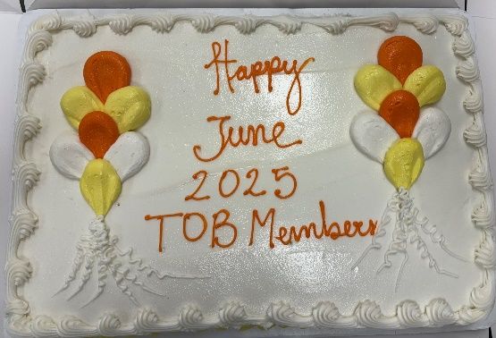
June: Rita’s Turkey Burgers with Sweet Potato Fries & Homemade Salad
Prepared with heart and healthy flair, Rita’s meal was a crowd-pleaser from the first bite. She teamed up with our kitchen staff to lead the prep and plating, bringing her signature warmth and attention to detail.

Food Service Unit
July 2025 Monthly – Recipe Meal: Caesar Chicken Salad Wraps and Birthday Celebration:
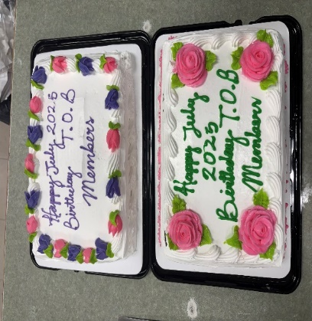
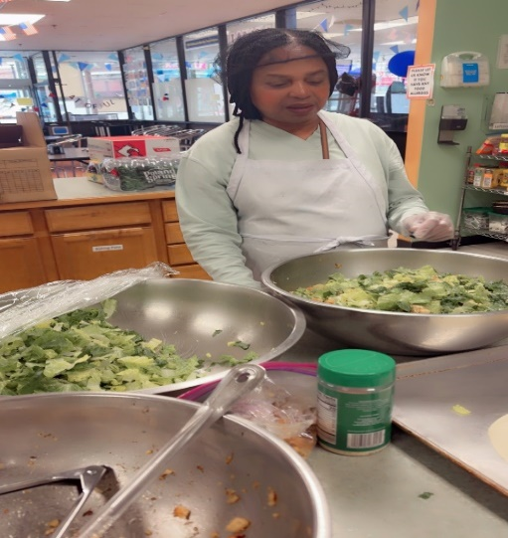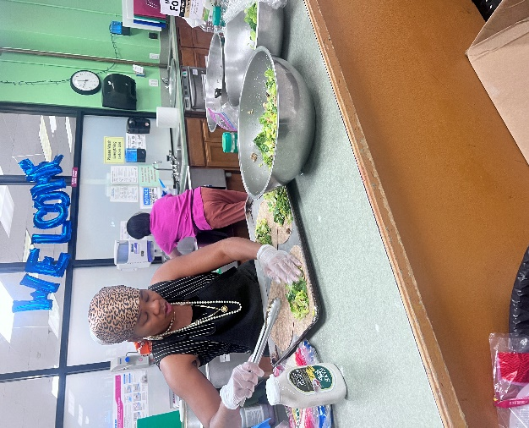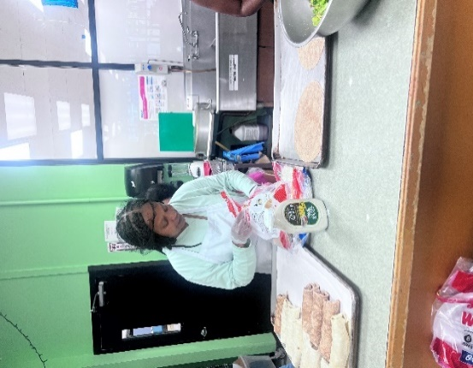
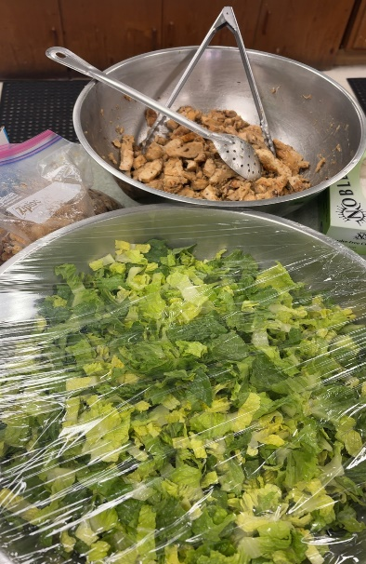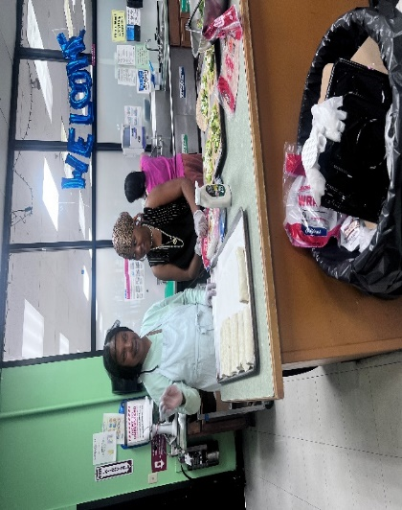
July: Priscilla’s Caesar Chicken Salad Wraps:
Priscilla brought fresh energy to the kitchen with her crisp, protein-packed wraps. With support from kitchen staff, she led the charge in assembling and serving this refreshing meal. “I love meals that are easy to share and full of flavor. These wraps are simple but satisfying, and they remind me of summer picnics with family. I wanted something that felt cool and comforting.” The wraps were a hit-perfect for a warm July afternoon and a great complement to our birthday festivities.

Got a Favorite Recipe? Drop it in the Box!
Rita and Priscilla’s meals were chosen from our Recipe Box, where members submit their favorite dishes for a chance to be featured as the next Recipe of the Month. Got a favorite dish that brings people together? Whether it’s a family classic, a creative twist, or a dish that brings you jpy- we want to taste it!
How to participate: Write down your recipe and drop it in the Recipe of the Month Box in the kitchen. If selected, you’ll get to help prepare it with kitchen staff and be featured in the next newsletter! Let’s keep the flavor flowing and the creativity sizzling. Who knows? Your recipe could be next! “In our kitchen, everyone’s a chef and every dish tells a story.”

Members Spot Light
Ralph’s Art Work

Members Spot Light (cont’d)
Ralph’s ArtWork

Members Birthday Celebrations


June July
Febru
Dejison Barros 07/03
Janet Scruggs 07/07
Syretta Copeland 0709
Louis Cyprien 07/09
Wallace Carpenter 07/13
Ronald Bryant 07/14
Omolayo Soremekun 07/24
Valerie Lucien 07/28

Emanuel Monteiro 06/03
Worku Aragaw 06/07
Adilson Centeio 06/08
William Howard 06/10
Desmond Springer 06/10
Kevin Armstrong 06/13
Daniel Edwards 06/16
Nathan Kindle 06/19
Akeila Jackson 06/20
Abigail Seicol 06/22
Ralph Kelley, III 06/23
Tina Smith 06/24
Kathryn Johnson 06/25
Eddie Cutanda 06/27
Apollo Gross 06/27
Paul Massop 06/27
Shawn Weathers 06/29



Check out our new webpage!
We will be posting upcoming clubhouse events.
Find us by searching “Transitions of Boston
Clubhouse” or transitionsofboston.org
All clubhouse news, information, outings, lunches, and so much more will be updated on a daily basis.

Contact Us
Give us a call for more information about our services.
1500 Dorchester Ave.
Dorchester, MA 02122
Phone: 617-379-5661
Transitionsofboston1@gmail.com

NONPROFT ORG
U.S. POSTAGE PAID
BOSTON, MA
PERMIT NO. 55903

Bay Cove Human Services
Transitions of Boston Clubhouse
66 Canal St
Boston, MA 02114

